

THE GOVERNMENT OF RUSSIAN FEDERATION
STATE BUDGETARY HIGHER EDUCATION UNIT
NATIONAL RESEARCH UNIVERSITY
«HIGHER SCHOOL OF ECONOMICS»

FACULTY OF WORLD ECONOMY AND WORLD POLITICS
International Program 'International Relations and Global Studies'

Thesis Paper
On the topic:

«Paths of Transformation of Italy's Energy Policy (2019-2024) »

By the student
of the 4th year,
group 211
Pachosik Alisa Igorevna

Academic supervisor:
Ostrovskaya Elena Yakovlevna

MOSCOW 2025
Introduction 3
Chapter 1 15
1.1 Approaches to Energy Security 15
1.1.1 Neoliberal Presumption of Energy Security 15
1.1.2 Energy Security Triad model perceptions 17
1.1.2.1 Sovereignty Perspective 17
1.1.2.2 Robustness Perspective 21
1.1.2.3 Resilience Perspective 24
1.2 Italian Energy Policy Prior to 2019: a Review of 2008–2019 28
1.2.1 IEA Policy Review Evolution: Report Comparison (2009, 2016) by sector 28
1.2.1.1 Renewable Energy Sector 28
1.2.1.2 Electricity Sector 32
1.2.1.3 Natural Gas Sector 34
1.2.1.4 Oil Sector 39
1.2.1.5 Coal Sector 42
1.2.1.6 Nuclear energy 43
1.2.2 Statistical Overview: 2016 - 2019 44
1.2.2.1 Electricity Generation 45
1.2.2.2 Total Final Consumption 45
1.2.2.3 Domestic Production 46
1.2.2.4 Total Energy Supply 48
Chapter 2 51
2.1 ‘Delivering the European Green Deal’ as a shaping factor 51
2.1.1 Italian measures to fit RED, EED and AFIR targets 57
2.1.1.1 Integrated National Energy and Climate Plan (INECP) 57
2.1.1.2 Italian National Recovery and Resiliency Plan (NRRP) 63
2.2 Sanctions as a shaping factor 70
2.2.1 Italian Response to post-2022 Energy Market Changes 76
2.2.1.1 Import Diversification & Infrastructure 76
2.2.1.2 Plan Mattei 87
Chapter 3 91
3.1 ‘Sovereignty’ glance at Italian energy transformation 92
3.2 ‘Robustness’ glance at Italian energy transformation 97
3.3 ‘Resilience’ & Neoliberal glance at Italian energy transformation 100
Conclusion 104
Reference list 108

Introduction
Relevance

The relevance of the chosen topic is polyhedral. First, Italy is one of key players in the EU energy market in terms of consumption. This is supported by the ranking of European Union countries in terms of primary energy consumption in 2023. Italy entered the top three, headed by Germany and France. The scope of the EU Italy not only matters for values of consumption but also its geographical position. Italian location in Southern Europe and its vast energy infrastructure makes it a Mediterranean energy hub for the EU. Against the backdrop of abandoning Russian gas after 2022 this feature acquired greater strategic importance. Second, European policy in recent years has seen a bigger rise in incorporation of renewable sources in the energy mix. Specifically, commitment to the environmental agenda is reflected in the adoption of such policies as the Green Deal and the REPowerEU Plan. In the context of the renewable transition Italy has achieved substantial results. The ratio o1f renewables in 2022 has achieved 20.4%, which exceeds the 2020 targets by 3.4%. Вescending from economical to the political level, Italy has developed a policy, aligning with European climate and decarbonization targets. One of them is the National Energy and Climate Plan, introduced in 2023. The newly developed both European policy in the light of available data and Italian national policy changes provides a field for its research. Third, the geopolitical tensions of the Ukraine crisis 2022 entailed restructure of the energy market. Prior to 2022 Italy was one of key buyers of Russian fossil fuels. In 2021 Italy imported around 40% of its total gas imports from Russia. Such a big share highlights the over reliance on supplier. However, the Ukraine crisis and following deterioration of relations with Russia compelled European countries to change their energy sector. Italy was not an exception, it also needed to find ways of compensating for the energy deprivation. The relevance is traced even beyond the time limits of research. Ukraine transit, one of the major gas pipelines which supplied gas to Italy, terminated its operation in 2025. By this time the five-year transit agreement had expired and sides did not extend it. Thus, the Italian energy policy of recent years has laid the foundation of its future development under challenging circumstances.
To infer, the time frames of the topic cover several recent events which reshaped EU energy policy. The choice of Italy is conditioned with its particular role and contribution.

Literature review
The literature covered the topic of Italian energy policy from different perspectives: approaching the issue, both approaching the issue broadly and focusing on specific areas.
A layer of academic studies focusses specifically on wide Italian security through the lenses of energy. Prontera (2024), Khan & Rapposellim (2024) and de Vincenzo (2022) limit their study with the Russian-Ukraine conflict 2022. In their paper Prontera (2024) highlights the energy diversification that both the government and the EU was forced to resort to. The Italian policy was realised with the support of such national actors asd ENI and Snam, which contributed to conducting triangle diplomacy with countries-suppliers and infrastructure building. Author concludes that such a geopolitical shift made Italy switch back to a partner state in the sphere of energy. The earlier works of Prontera prove the changing nature of Italian energy strategy. Analysing Italian energy policy from the historical perspective, the author emphasises the changes in policy caused by the 2008 financial crisis (Prontera, 2018). Italy took the role of ‘hub of gas’, meaning the increased role of Italian gas infrastructure for the EU market, taking into account the uniqueness of its geographical position. However, prior 2022, Prontera (2018) characterised Italy as a catalytic state, meaning mobilizing resources within the EU coalition to pursue its objectives. Thus, crises served as an impetus for shaping Italian energy policy in the last decades. Continuing the review with focus on the post-Ukraine, Khan & Rapposellim (2024) claim that the events of 2022 highlighted the importance of energy security for European states. Authors evaluate the Italian energy portfolio, acknowledging Italian dependency on natural gas import. The contribution of the paper is providing arguments for incorporating the consumption of renewable energy and spotlighting the obstacles towards transition to green energy. So, Khan & Rapposellim (2024) approach the energy security of Italy through the diversification of energy sources. The ‘green’ side of the energy transition accelerated by the Ukraine crisis considers de Vincenzo (2022) in their work. The argument is supported by several initiatives, including the European-level NextGenerationEU program and the Italian Recovery and Resilience Plan, both designed to advance the goals of the Green Deal. Scholar claims that this geopolitical event proves the EU necessity to securitize itself, abandoning Russian supplies and diversifying energy flows. The analysis of European energy policy during the 2022 crisis should focus on the specific role of sanctions and their implications. Batzella's (2024) study analyzes the preferences of EU member states regarding the formation of energy sanctions packages, providing interesting insights. First, member states have managed to exclude certain energy sources, such as gas and nuclear energy, from the scope of energy sanctions. Additionally, after extensive rounds of negotiations, measures to restrict energy consumption have been increasingly adopted and have primarily targeted coal and oil sources. Second, energy sanctions have been implemented simultaneously with specific energy policy initiatives, such as the EU Energy Platform and REPowerEU, aimed at mitigating consequences and accelerating the transition. Hence, the EU seeked to sanctions Russia in a safe manner for itself. Proceeding on the decision-making on energy sanctions, Oana et al. (2025) emphasise that Italy among countries with lowest level of support. Article findings show that public support for measures against Russia is present, although the level of sanctions support varies from member state to member state, and in this light, a number of potential domestic conflicts are possible. In their turn Nugrahani (2024) approaches topic analysing european responsive policy change and concrete measures to reduce dependence on energy imports from Russia. Scholar states that EU policy is characterised as a comprehensive one, which resulted in several projects. Hereby, in the light of the energy crisis the REPowerEU was supposed to make a substantial contribution, diversifying energy sources, using contractual relations and resulting in expanding the proportion of renewable energy sources. As for reducing the import of Russian oil and gas, the solution for the EU was the inclusion of LNG imports from America and natural gas from Norway and Algeria. Thus, the EU response was diversification and acceleration of energy transition in order to preserve stability and energy security.
The Russian-Ukraine conflict despite sanctions impact, entailed another sort of blow. Nascia et al. (2023), in their study, address the inflationary crisis that occurred in the European energy market during 2021 and 2022. It was caused by rising Russian-Ukraine heated relationship resulting in prices increase on imported energy. Authors narrow focus to Italian case, analysing its impact mitigation measures. Responses can be divided into domestic and external oriented. The first group includes tax credit schemes, to support households; and stress on renewables in energy production. Another group consists of addressing energy supplier’s heterogeneity, to avoid gas shortages. The paper provides an economic glance at Italian actions under inflationary circumstances, emphasizing employment rate, business and tax dimensions. Simone and Pianta (2022) provide a similar economic vision on Italy’s response to inflation. However, while the work of Nascia et al. (2023) is diluted with policy analysis, here Simone and Pianta (2022) use primary comparative macroeconomic analysis. The consequences of disruptions in Russian gas were also observed by Amaglobeli & Roaf (2022) but from a different angle. First, the paper's character is a forecasting one, predicting impact on GDP. Second, the research is conducted via the prism of policy and network facilities. The study ranks European countries according to their vulnerability to Russian gas dependency, from the most vulnerable to the least. Scholars label Italy’s zone of risk not as high as Central and Eastern Europe, but significantly sensitive. The distinguishing feature of study is the presumption of infrastructure bottlenecks as a risk multiplier. This idea author applies to Italy. In the light of green initiative authors mention Italian renewable potential which is supposed to soften the blow. Still, scholars predict that Italy would suffer less than Germany. In general, Amaglobeli & Roaf (2022) described the EU response policy as flowing from immediate policy priorities to collective actions such as RePowerEU.
Some scholars view the issue of energy security through the prism of comparison. Krikštolaitis et al. (2022) estimate the level of energy security of Germany, France, Spain and Italy, comparing the composition of energy fields in the 2006-2018 period. The authors' findings suggest that Germany and France outperformed due to factors such as a diverse energy mix and the presence of nuclear power plants. While Spain and Italy are in chains of dependence on imports and a disbalanced energy portfolio, their security in terms of energy is more vulnerable. Among selected states for study, Italy has the most fragile position. One of the reason - abolishment of nuclear energy. Di Nucci (2006) dedicated a paper on this topic, covering the Italian leading role in the early development of nuclear energy, which promised to be a positive contribution in conditions of the scarcity of domestic fossil fuel reserves. However, the situation on the oil-market in the 1960s with a number of other factors contributed to the curtailment of nuclear initiative. The Chernobyl disaster followed by the referendum put an end for Italy to this direction of energy. According to Di Nucci (2006), despite the fact that return to nuclear energy is not foreseeable, ENEL invests in development of nuclear plants abroad. Thus, this layer of literature provides general understanding of recent Italian energy poliсy in step with the European one and its structural constraints. Nonetheless, there is another area of studies which mainly focus on the narrower domain of Italian energy.
The growing emphasis on transitioning to sustainable energy has led to a substantial body of research dedicated to exploring various aspects of this topic.
Generally, an academic consensus on idea that green energy transition for europe is
crucial for securitizing its energy prevails. Pastore & de Santoli (2025) claim that for Italy this transition would require significant costs and the velocity of its realisation depends on fossil fuel costs. The main argument of the authors is that the volatile prices of fossil fuels in recent years are a reason for a complete transition to renewable energy sources. Still, technical and economic hurdles towards sustainable goal achievement exist (Armaroli & Barbieri, 2021). Article states that the production of green hydrogen, required to reduce carbon emissions, is currently more expensive than traditional processes and relies on significant breakthroughs in technology. Additionally, Armaroli & Barbieri (2021) believe that current prioritising of hydrogen shifts focusses from more effective short-term solutions like direct electrification, which might suppress broader decarbonization effort. Achieving the EU's climate objectives requires a balance between hydrogen development and other renewable energy technologies in composition with correct policy decisions. A long-established relevance of energy transition is reflected in public debates (Brondi et al. 2014). Scholars argue that despite the fact of politicians' acknowledgment of the necessity of sustainable energy development, the public opinion on this issue remains omitted. In this context political rhetoric and public opinion formation function independently, as evidenced by the lack of a temporal connection between the subjects covered by the press and those debated in political forums. The findings of Brondi et al. (2014) indicate that the centralized Italian system provides no place for citizens' representation. Mass media should prioritize the topic of energy transition, fostering greater public engagement and transforming citizens from passive observers into active participants in the process. Nonetheless, currently, there appears to be a shift in the prevailing trend. Candelise and Ruggieri (2020) concentrate on a narrow aspect of Italy's energy transition – community energy initiatives – which they argue are central to increasing citizen involvement in the transition to cleaner energy systems. This sector remains underdeveloped: only several initiatives succeed in evolutionasing to national level, while the majority operate in the local, ad-hoc form. However, their findings highlight that recent national legislative changes have created a more favorable framework, fostering the growth and further development of energy communities. Continuing the topic on the role of specific actors in energy transition, Bertolini & Blasi (2021) examine the contribution of distribution system operators (DSO) in decarbonization. In the case of South Tyrol, they illustrated that this region plays a promising role in shifting energy sources to renewables. While DSO should maintain high levels of population awareness of choices in terms of resources. Knodt & Kemmerzell (2022) studying the historical development of Italy's energy sector, with particular emphasis on its evolution as reflected in the composition of the national energy mix. Findings show that in 2017 one third of Italian energy production was consumed by the transport sector. This trend demonstrates an important role that sustainable mobility can play in transforming national energy, especially in the plan to reduce carbon emissions by 2050. The main contribution of study is the democratisation of the national energy landscape which should be expressed in opening up the energy market to new entrants. This trend of power shifting toward localization, according to Knodt & Kemmerzell (2022), should result in focus shifting from renewables to energy efficiency. Di Nucci & Prontera (2023) argue that the rising decentralization trend in the energy field brought contradictory results. On the one hand, the energy transition was hampered by the multilevel system. Conversely, it established reciprocal mechanisms that promoted the growth of renewable energy sources. Additionally, authors believe that the National Recovery and Resilience Plan (NRRP) is expected to make a weighty contribution in accelerating Italian energy transition which is in high dependence on gas. Therefore, the academic community concurs with the heightening prominence of green energy in Italy, overcoming obstacles lurking in political structure, citizens awareness, technologies and high required costs. Despite all listed obstacles, the observed literature represents an optimistic glance on the decarbonization trend.
In recent years the Italian government has launched a number of projects as part of energy policy, independent from the EU. Among these is the Mattei Plan, which has been analyzed in detail by Lumeno (2024) and Simonelli et al. (2024). In their study Lumeno (2024) overviewed the change of Italian relations with Africa through the prism of the Arab Spring. The will of addressing regional challenges resulted in enhanced economic engagement with African nations and diplomatic evolution. The study does not focus on the economic implications of the topic but offers valuable insights into the shifts in Italian-African energy relations in the aftermath of the Arab Spring. However, the timeline of this event does not align with the launch of the Mattei Plan. Lumeno (2024) concludes that the Mattei Plan was designed to use Italian geographical position in increasing regional security, enhancing economic engagement with African nations and diplomatic evolution. This strategy enables Italy to succeed in establishing itself as a crucial partner between the EU and Africa. In turn, Simonelli et al. (2024) analyses the Italy-Africa summit held in January 2024 in Rome. Authors focus on theses put forward during the summit, particularly the importance of fostering economic cooperation, addressing challenges related to migration and the necessity of correct realisation of concept ‘cooperation as equals’. Moreover, Simonelli et al. (2024) write that the spectre of representatives from African nations on summit was not complete, important players were missing. Study concludes with the thought that Italy should act more decisively in the way of Plan realization: integrating it both on institutional level and state level. Hence, there is a lack of research on Plan Mattei economic realization. Ones that exist show the dynamics and the backgrounds of its gradual realisation.

Research gap, question and hypothesis
Summarizing the literature observed, Italian policy of energy has been analysed across various timeframes and from multiple perspectives, including the green transition, energy mix and security, the impact of sanctions, as well as national initiatives and policies. Nonetheless, there remains a lack of comprehensive research specifically focused on Italian energy security, as opposed to the broader framework of the European Union. This gap is particularly evident in the context of the period beginning with the launch of the Green Deal and encompassing a wide range of policy implementations. One of the important aspects to study is the alignment between European initiatives and national strategies across different directions of energy policy. The research aims to fill these gaps via analysing what caused the evolution of Italy's energy policy and detailing the set of measures that were utilized in the process. Italian energy policy is the objective of the research.
Hence, the research question is as follows: “How has Italy's energy policy been transformed after 2019?”
Hypothesis: “After 2019, the Italian government was forced to transform its energy policy, taking into account the influence of new factors such as European Green Deal adoption and reduction of Russian energy supplies. As a result, Italy’s energy policy became more multi-vector, covering green transition, imports diversification and expenditures on infrastructure”

Goal & Structure
The aim of the paper is to structurally assess the transformation of Italian energy policy that was shaped under events, happened within the 2019-2024 period. To trace changes, research has the following structure. Chapter 1 provides a detailed explanation of theories used in paper. Then via comparison of IEA reposts, the paper analyses the historical background of the Italian energy landscape. Chapter 2 defines and analyses two major factors that impacted the Italian energy landscape. The scope of the factors, observed in the article, is limited in order to suit theoretical frameworks. Thereafter, the paper analyses the measures that the Italian government implemented to adapt, based on limitations of factors. Finally, Chapter 3 takes findings and approaches them through theoretical frameworks, providing an answer to research questions. Thus, research identifies shaping factors and Italy’s polity to adapt for them.

Theoretical Framework & Methodology
The study implements neoliberalism and Energy Security Triad as theoretical frameworks to narrow the glance at the topic. Neoliberal approach is suitable for the Italian case as it explains energy policy through cooperation and complex interdependence between states. It is suitable for Italy, as a member state of the EU, to align its national policies with the goals and regulations of the Union. In turn, the licences of Energy Security Triad allow us to approach energy policy from three different dimensions. Each of the perspectives sheds light on a specific area of the energy system based on identified threats. One of triads’ perspectives allows them to study the Italian energy landscape apart from the EU. Nonetheless, other perspectives build the bridge towards neoliberalism. So, theories are not mutually exclusive and can be applied to the case of Italy simultaneously. Such a theoretical combination provides a systematic way of comprehending the evolving Italian energy policy.
Regarding the research design, the study uses a mixed methodological approach. As for qualitative methods, research includes policy analysis, which is based on analysis of contextual data from official documents and websites. Moreover, the paper compares documents in Chapter I in order to gain a profound understanding of recent history Italian energy policy. The quantitative approach is represented in applying statistical analysis and graph description. Combination of these methods allows us to study the topic from different angles, numerically confirming findings.
The research focuses mostly on policy of supplier diversification, resource diversification, investments in infrastructural landscape. These areas of focus limit study. Thus, the economic policy of challenges response is out of the scope. Moreover, in spite of the fact that the REPowerEU initiative meets the time limits of work, it is out of the study scope. National Recovery and Resilience plan and National Energy and Climate plan are main documents, which are analysed to study Italy’s alignment with the EU in the Green Deal. The study has also faced the lack of official data on fossil fuels imports after 2021.

Chapter 1

1.1 Approaches to Energy Security
The concept of energy security is a widely discussed topic in both academic literature and political discourse. Countries prioritize the safeguarding of their energy supply chains, particularly during periods of instability, in order to ensure a reliable and secure energy supply. Researchers use energy security frameworks to analyze the characteristics of energy systems, considering their geopolitical, economic, political, environmental, and technological aspects. Still, despite the fact of the prevalence of energy security as a concept, we should not get it for granted. On the contrary, special consideration should be given to versatility of the energetic side of security, as the complexity of concept can lead to misunderstandings. Numerous lenses exist which help to narrow the view on the energy, focusing on specific its’ aspects and providing specific criteria for its measurement. Given the complex and dynamic nature of this notion, it requires thorough explanation when employed in academic work. This research implements neoliberalism and energy security and theories.

1.1.1 Neoliberal Presumption of Energy Security
Neoliberalism in the International Relations landscape emerged as a response to the limitations of classical liberalism and the rigidities of neorealism. To gain a deeper understanding of neoliberal framework it is often compared with neorealism. Both theories arose as rival but complementary reactions to the limitations of classical theories and the shifting contours of the Cold War setting. To begin with, the licence of neoliberalism changed orientation from liberal emphasis on individual freedoms to economic freedoms. The theory believes that states’ cooperation supported by institutions and regimes contributes to stability and peace. Institutions within neoliberalism are given a distinct role, underscored by Keohane (1984). They act as tools for facilitating long-term cooperation by means of reducing transaction costs, providing information, and making commitments credible. This mechanism enables reciprocity, increasing states' readiness for increased interconnections. Putting it in a broader context in the international arena, institutions help states to minitage risks to which they are exposed in an anarchical landscape. In the light of the unpredictability of the external political environment, the development of complex interdependence decreases states’ benefits for entering into conflicts. The term ‘complex interdependence’, introduced by Keohane and Nye, sheds light on areas for cooperation beyond military power – economic and environmental cooperation. The expansion of links between states is a crucial thesis for neoliberalism.
If neorealism adheres to relative gains logic, which is close to zero-sum game, neoliberalism states for possibility to achieve absolute gains. It means that benefits can be distributed equally among parties without deprivation on someone 's part. States are supposed to be happy with their situation and, thus, they are not preoccupied with how others are doing. It results in circumstances where states seek to improve their own welfare regardless of others' gains.
Framing the theory in an energy security context is necessary for its implementation within research. First, energy security can be approached as a collective good, which is achievable through collective actions. This is an ‘absolute gain’ which is securitizing without taking away the security of others, but developing an international balanced energy network. The European Union joined energy policy is a vivid example of theory implementation. Second, sharing norms of international regimes via sharing membership in organisations, contributes to stabilization on energy markets. Going beyond theory, it is institutions such as the IEA or WTO which form communities, establishing some regulations and common goals. Third, commitment to interdependence in multiple spheres mitigates conflicts between those who share neoliberal norms. The point is that benefits from cooperation outweigh possible benefits from unleashing a conflict.

1.1.2 Energy Security Triad model perceptions
This study uses the Energy Security Triad model, as formulated by Cherp and Jewell (2011), as a theoretical base for the conceptualization of Italy's energy policy. The framework, founded on the evolution process of energy systems and the evolution of social sciences, distinguishes three underlying dimensions of energy security. The discussion that follows is organised so that each of the perspectives presented by Cherp and Jewell (2011) has brief historical foundations before delving into a thorough explanation of these ideas.

1.1.2.1 Sovereignty Perspective
Throughout history, social attitudes toward energy sources have evolved in tandem with their utilization which gave rise to energy dimensions. Scholars in their paper distinguish World War II as a turning point that shaped the international energy landscape, as access to oil emerged as a decisive factor for military operations and national security strategies. Several countries, including Britain, Japan, and Italy, decided to change the sources of energy, switching from domestic coal to imported oil. The shift to oil was driven by technological advantages that outweighed price considerations: price on oil was higher than on coal. The global conflict created a linkage between security and access to fuels for the military. The reason for such a tendency was the need for oil for keeping military equipment running. In the light of geopolitical restructuring and upheaval states had to keep military blocks equipped in order to safeguard national defense capabilities. Hence, the connection between energy and security has reinforced and has acquired a different character. The historical trajectory demonstrates how oil expanded its significance beyond warfare into broader economic and industrial domains. Petroleum became a life-giving moisture for production processes reliant on oil derivatives, a cornerstone for countries dependent on revenues from its export, and an essential component of logistics and transportation systems. The crisis of 1973 disclosed the weaknesses of the system tied to petroleum. The theoretical problems of dependence of industrialized countries on imports have taken on real forms. Countries with the biggest reserves and most influential on the energy market, such as OPEC members, cut their oil production, skyrocketing prices on oil. Thus, oil crises became a living proof of the fragile nature of the energy market. As a response several steps have been taken. First, were established international regimes under which the probability disruption of oil supplies would be reduced. Second, the notion of an international oil market was reapproached: a large number of participants should prevent any one party from controlling too much of the industry. Third, the International Energy Agency (IEA) was established. The members of the agency had emergency oil supplies in order to neutralise any possible disturbances. However, these measures were not enough. Not willing to become a victim of supply failure, friendly countries such as Canada, developed oil-industry and increased the volume of oil production. This would decrease dependence on unreliable suppliers, by adding more stable suppliers. In addition, the diversification of energy portfolios was promoted, with states beginning to develop nuclear and gas as new energy sources.
For a considerable part of the 20th century, oil supply protection was the most politically prominent obstacle to energy security. The demand on oil by military operations and industrialized economies rendered its continuous availability a paramount interest. The most evident source of threat was an anarchic system in which actors acting in their interests can commit malicious acts. The oil crisis of the 1970s demonstrated that petroleum can be used as a strategic tool with the aim to influence political outcomes. Energy security was approached mainly through the political way of thinking, highlighting the connection between peaceful and military means of protecting important resources.
The historical context that underlies the sovereignty perspective on energy security has its roots in the era of dominance of strategic security studies, international relations theories, and political science. Prior to examining concepts from the other side, it is important to clarify that the lens of sovereignty framework in energy security was formulated during a period when these fields were particularly influential. This school of thought's analysis of energy security focuses on how various players' interests, power, alliances, and flexibility are arranged.
The second half of the 20th century highlighted the key vulnerability of this approach: dependence on foreign-controlled energy resources and suppliers. States relying on energy suppliers to become a victim of malicious use of market power. Energy supply is vital for the survival of a state heavily dependent on external energy sources; however, the reliability of this supply is not entirely within the state's control. Among other potential hazards existing in the structure of the system are ones which have political consideration and violence: political embargo and terrorist attacks on critical infrastructure. States' deviant behaviour in the political arena can be penalized by other actors through the imposition of sanctions targeting critical sectors, such as energy exports. This dynamic was exemplified in the EU-Russian relations following 2022, when the European Union implemented extensive sanctions on Russian energy exports in response to Russian distributing peace actions. There is also an example on infrastructure attack from recent history: Nord Stream pipelines sabotage occurred in 2022. This event reshaped the structure of the European energy market. In summary, within this system demand side could suffer due to external actors or environmental factors, circumstances of which are not subject to planning. Nonetheless, the sovereignty perspective offers ways to mitigate risks: protect key energy facilities, maintain control over energy systems in political and economic dimensions, selecting trusted suppliers and switching to domestic resources when feasible. A set of listed tactics can be formulated into specific responses, including maintaining emergency stocks for unforeseen and undesirable events, participating in ensuring competitive energy market conditions, and diversifying supply routes. While emergency stocks serve as a safety cushion, reducing market barriers and fostering a competitive environment can open up opportunities for a greater number of energy suppliers. From the demand side, this condition is the path towards avoidance of overdependence on one supplier, allowing easy switching among them. Thus, the competitive landscape enables actors to diversify their energy sources. Diversification can be approached in another mode – diversification of energy sources. In sum, using such a strategy is useful for mitigating risks and reducing unnecessary costs in case of a crisis. It also can be achieved by investing in regional infrastructure involved in energy production and logistics. This approach helps stabilize energy markets by spreading dependencies across multiple sources, thereby minimizing the economic impacts of political or operational failures.
Summarizing up, the energy security perspective of sovereignty was born under the influence of security and political studies. The flow of history, namely crises that shook the geopolitical and economic landscape, has provided objective impetus for states to develop and sustain new energy systems. As a response to these circumstances ‘soverenitive’ school of energy security was formulated. Nonetheless, there is a prevailing belief that these risks can be effectively managed through strategic measures and policy interventions.

1.1.2.2 Robustness Perspective
The subsequent phase of historical and science development leaking in the beginning of the 21th century laid the groundwork for the robustness perspective. The scientific community has learned from the previous century, which are formulated into two dominant ideas. First idea attributed to Yergin (2006) came up with consideration of the extent to which current energy resources can meet future demand. This leads to the recognition of the finite nature of resources, especially, oil reserves. Second concept has its origins in technological science. Lovins & Lovins (1982) studied the United States’ electricity system. The main takeaway was the acknowledgment of the fact that US national systems are subject to serious technological failures owing to systematic reasons. Under the auspices of these two ideas the robustness perspective developed.
At the turn of the 20th and 21st century, a series of crucial failures occurred, resulting in catastrophic nuclear outcomes. In part, these are echoes of actions taken after 1973 with the aim for states to differentiate energy portfolios. Although, the other side of the coin is the increasing complexity of energy systems also heightens the potential for human error. Сonsequently, in the second half of 20th century Three Mile Island (1979) and Chernobyl (1986) nuclear catastrophe took place in the US and former USSR, respectively. Additionally, the Fukushima accident happened in 2011. Besides human casualties and environmental problems these disasters entailed long-term political implications. The perception of nuclear energy – originally regarded as a means to diversify energy sources, reduce import dependence, and enhance energy security – underwent a significant shift. A series of disasters revealed a dangerous side of having nuclear power plants. In this sense, the Chernobyl disaster became a turning point for many European states which decided to abandon nuclear production within their borders. Some states abandoned nuclear power directly through a referendum or imposed a moratorium via referendum after Chernobyl, others came to this decision through the political process. Italy in 1987 held a referendum in which the majority of citizens supported repealing laws that enabled nuclear plant construction and operation. As a result, by 1990 nuclear reactors were shut down. In Germany this was a more time-consuming process. The Chernobyl disaster rallied and strengthened anti-nuclear sentiment and commitment to environmental values. From the 2000s there were attempts to unfold nuclear shut down policy but it was not fruitful. But the Fukushima disaster has become a catalyst for a long-planned nuclear phase-out. Thus, in 2023 Germany closed three of its nuclear power plants. Austria Belgium are examples of other countries influenced by a wave of nuclear disasters. Either way, nuclear power evolved from the source of energy security to the source of disaster, dividing countries in two camps: ones who support nuclear energy and ones who abolished it. For the present, France has the largest nuclear fleet in Europe, largely relying on electricity generation from it. Examples of other ‘supporters’ are Finland, Hungary, Slovakia, Czech Republic. Netherlands plans to expand its nuclear field. Poland, planning to build a nuclear power plant by the 2030s. As for another camp, among its representatives are Italy, Germany, Denmark, Austria, Luxembourg, Portugal. Opinions in some countries on the issue are divided. For instance, in Spain where nuclear generation is present, there is no strong support for its existence. Or Belgium in which phase-out law was in place but the timeline of abolishment was postponed repeatedly.
Except for the historical events, the state of the infrastructure had an essential impact. This fact had an effect even on nuclear power. By the early 21st century, nuclear facilities in developed countries, along with the industry’s workforce, began to show signs of aging. It was one of the triggers for searching alternative ways for electricity generation. While human and technical mistakes relating to reactor design and operational failures were the main causes of the Three Mile Island and Chernobyl nuclear accidents, a natural disaster – more precisely, a powerful earthquake followed by a tsunami – caused the plant's safety systems to fail at Fukushima. The nature of the Fukushima case demonstrated how natural conditions can impact the energy industry. This idea was elaborated further under a robustness perspective. In the latter half of the 20th century, as energy systems became more complex, industrialized societies grew increasingly vulnerable to even brief disruptions caused by sabotage, terrorism or technical failure. Making an inference, this historical block is characterised with two milestones: nuclear disasters and increasing vulnerability of energy systems. Hence, in this era of new susceptibilities, the need to ensure the reliability of existing systems has increased.
Taking into account the geopolitical nature of risk studied by the sovereignty stream, the need for other approaches arose. This was supposed to lift the geopolitical curtain for politicians by expanding their horizons. This trend was also influenced by a new type of threat, distinct from the sovereignty perspective, where challenges arose from political motivations. Predictivity is another feature that makes a difference between two dimensions. From the standpoint of natural sciences, objective risks are those that can be quantified, such as resource scarcity or natural disasters. While the engineering perspective identifies measurable hazards as issues like aging infrastructure and technical failures. Both approaches contribute to a structured understanding of predictable risks, enabling targeted strategies to minimize disruptions. Engineering studies played a role in minimizing susceptibility of energy systems. The findings and recommendations from these studies were reflected in political implications. It included introduction of technical standards regulating backup generation capacities, early warning and load distribution systems. Through the licence of robustness, it is possible to minimize risks via infrastructure upgrading, switching to safer technologies and transition to more abundant resources. The paradigm of robustness intersects with sovereignty in response to energy security violations, leading to a common strategy – maintaining emergency stocks. However, this response is not the only thing that offers a robustness paradigm. Among others are having reserve capacity to handle peak demand or unexpected outages, ensuring redundancy of infrastructure to avoid single points of failure. The listed measures can be applied to enhance the resilience of energy systems. For instance, reserve capacity and emergency inventories allow energy systems to respond to supply or demand changes without loss of reliability, which provides an assured supply of energy in the event of unplanned disruptions.
Hereby, the robustness perspective originated under the influence of cataclysm and the changes in infrastructure. The dimension oriented on resilience offers a glance, focusing on predictable risks. In this scope the tools of risk management exist and can be realised through policy. Using the robustness steam does not mean to refuse from political and institutional analysis. However, it requires broadening horizons beyond geopolitical perception and shifting focus to the technical side of the energy industry.

1.1.2.3 Resilience Perspective
Last but not least, the approach emphasizing resilience was developed during the period of market deregulation. The liberalization policy took place in a number of countries during the 1980s-1990s, characterizing it as shifting from a state-centric approach to market mechanisms. The supporters of deregulation strongly believed that transferring power to other actors would make the energy market more efficient. Easy entrance to the market would guarantee the number of actors, and the market would be a competitive field of players of which would be interested in infrastructure maintenance and provision energy in an efficient way. These changes in market structure were supposed to bring other beneficial outcomes. Transferring power from government to private companies is an attempt to make the energy field out of politics. As a result, this approach of depoliticizing energy should have to reduce the possibility of hazards that have roots in political motivations. The perception of energy was also expected to evolve: from viewing energy as a political tool to recognizing it as an essential necessity. The rebuild of energy market structure was aimed to ensure stability, diversifying actors and reapproaching energy as a concept. Nonetheless, historical events showed that this novelty does not protect either from crises. For instance, the energy crisis in California in the 1990s, which was brought on by private market participants' manipulation. Consequently, a series of such events highlights that still actors can be unscrupulous, creating obstacles for market independent regulation. The unreliability of private entities as actors can be traced in other directions as well. The foundational principle behind an ideal liberalised market stands that companies ‘invisible hand’ of the market should balance supply and demand. However, in reality, companies pursue their interests, as a rule, commercial objectives. This imperfection can be transferred to the energy security question: the way of managing investment portfolios. Instead of investing in critical energy infrastructure and facilities, companies can spend money on projects or assets with more favourable short-term returns or more closely matching shareholder expectations. Generally, risks from the viewpoint of resilience are unpredictable. These changes in structure are parallel to changes in the scientific field in approaching energy security. Economics emerged as a leading discipline, shaping both theoretical frameworks and policy strategies. First, the view on energy was reapproached from tangible availability to its price. Second, the economic way of thinking resulted in the rise of portfolio management theories as a response to power supply stability failures.
The steam of security perception defines threats as circumstances which are unpredictable and uncontrollable. The reason behind such judgment is multifaceted understanding of the world. The prism of resilience recognises the complex nature of societies, technologies, markets and energy systems themselves. A variety of issues can be termed 'unpredictable,' such as those with economic, natural, technological, and political origins. Adding further specificity, these factors include market volatility, climate change impacts, shifts in policy of regulatory, and technological advancements or failures. The nature of source of energy insecurity draws the big difference between two higher described perspectives and the resilience one. Sovereignty and robustness streams in view of predictability of risks provide risk minimization strategies. In turn, resilience, approaching the world as a box which is full of unpredictability, can not neutralize dangers. Generally, to deal with risks, the response of resilience is to equip energy systems, ensuring their flexibility, adaptability and diversity. Notably, this strategy is suitable for both predictable and unpredictable risks. As for specific responses, resilience dimension unites all actions considered by others perspectives: heaving emergency stocks, diversifying sources of energy, ensuring competitive market landscape, having spare capacities, abundance of infrastructure. Thus, having a complete difference of observed dimensions of energy security, this also can be named as an origin of similarity between three of them. In other words, the wide view of resilience unites the two perspectives.

Combining three dimensions
It is worth highlighting, despite the core differences among three observed dimensions higher, there is an intersection, labelled ‘generic responses’. The three concepts come down to recommended solutions, which are aimed to securitise the energy sphere. First, minimizing the amount of energy required for production leads to increase of energy efficiency and reduced demand. Consequently, reduction in energy intensity is a way to make the economy less sensitive to disruptions, enlarging its resilience. Second, diversification in energy alternatives reflected both in the number of suppliers and the composition of the energy mix. Building up the number of external interconnections and developing homegrown energy is also a shield for threats from each of perspectives (ibid). Third, investments in research and development of institutions of energy, results in building more robust infrastructure, information, transport systems, contributing to their flexibility (ibid.).
Such an overlap is conditioned by two important concerns. The trend on separating challenges to energy security has changed. If earlier emerging obstacles have been addressed independently, then now this approach is not suitable anymore. As far as the energy systems have evolved in their complexity, the nature of challenges has become intricate one. Hence arises the second consideration, there is a growing need for comprehensive strategies to tackle energy issues in an effective way. Considering this claim from a theoretical point of view, it suggests the intersection of sovereignty, robustness and resilience lenses, the convergence of which has resulted in generic responses.

1.2 Italian Energy Policy Prior to 2019: a Review of 2008–2019

1.2.1 IEA Policy Review Evolution: Report Comparison (2009, 2016) by sector

In order to get a more profound understanding of the rhythm of energy development in Italy, the paper makes an overview of the IEA report 2009 and the IEA report 2016 and compares them. The comparison is being made in accordance with the document's structure. It focuses on policies, infrastructure, market structure within each sector. It is important to note that the IEA 2009 report reflects 2007 statistics, while the IEA 2016 report uses 2014 data.

1.2.1.1 Renewable Energy Sector
Over the years there has been an increase of both the government attention to renewable energy sources (RES) and, consequently, their role in the Italian energy mix. Supporting the positive dynamics with statistics, the share of RES has risen from 7.9% in 2005 to 18.2% in 2015. RES has become more actively used within all sectors, especially due to heating and cooling, electricity and transport industries. Focusing on the logistic sphere, in the beginning of 2000s a number of laws regarding taxation were designed to promote usage of biodiesel. Comparing designated periods, the consumption of biodiesel grew almost three times; however, despite attractiveness of tax conditions, in 2007 the proportion of biofuels to diesel was 0.53%. Such a low ratio can be explained with the fact of the early stage of renewables incorporation and the high costs of biofuels production. By now, the share of biodiesel has increased to 7-10%, which corresponds to the B7-B10 standards. The shift in percentages shows how the policy was successfully incorporated, bypassing difficulties. In the scope of IEA, Italy occupies 11th place in terms of share of RES. Assessing the statistics of 2023 among EU countries, Italy is in 14th-16th position in renewables share (European Commission, 2024).Germany and Spain, for example, lead the top 5 wind and solar countries in 2020, while Italy occupied 11th place . In Germany the higher wing and solar share – 32.7% in 2020 – is driven by onshore wind dominance, while Italy lacks wind resources. Spain has similar solar PV potential but costs are lower. Initially Spain used feed tariffs, but in order to control costs and avoid market saturation, the country transitioned to auction-based mechanisms. In fact, costs are lower, compared with Italian, while solar photovoltaic share (solar PV) is high. After 2016 Italy has been switching from feed-in tariffs (e.g., Conto Energia) to auction-based incentives, managed by GSE. Auctions act as guarantee that lowest cost RES-projects would receive support. New measure contributed to cost-efficiency, cutting subsidy costs and technological innovation progress.
Over the period, hydropower and biofuels have reserved the leading position among other RES. While the IEA 2009 report criticises Italy for having a gap in solar PV and wind power, a large growth in a decade was achieved through investment development in this type of RES. By 2015 Italy had become a country with the third largest share of solar power among IEA, accounting for 1,6% in total primary energy supply (TPES). The share of renewables in electricity generation demonstrated a notable increase also, shifting form 16% in 2007 to approximately 38% in 2014. While in 2009 hydropower was the main contributor, by 2016 the trend started to change, making solar PV and wind leading and declining hydropower share.
Despite statistical overview, there has been a change in policies, which should be underscored. The period up to 2009 can be labelled as the initial stage of adoption of EU 2020 targets in terms of RES. Consequently, the policy on RES was in the ‘embryo stage’, poorly elaborated in comparison with later periods. Going in detail, IEA 2009 in-depth review of Italian policy focuses on measures designed to stimulate usage of RES. Among them special positions occupying green certificates and feed-in tariffs on hydro and biomass. The tradable green certificates scheme, elaborated in 1999 and operated up to 2012, obliged producers of non-renewable electricity to incorporate annually a minimum quota of renewable electricity. This mechanism is labelled as a market-driven one. The system of feed-in tariff based on offering price stability via long-term contracts to energy producers, was also on the introductory stage. Furthermore, in this period the government increased investment in solar power development. The experience of the period prior to 2009 demonstrated the obstacles towards RES expansion at the local administrative levels. This kind of institutional complexity limited investment in renewables development due to difficulties in getting permissions. As a whole, the renewable energy policy up to 2009 aimed to increase the share of RES both in TPEC and electricity. Still, the critics state that use of financial incentives are risky. Second, more fundamental critique, accused stimulating schemes of being inefficient in addressing underlying reasons of slow RES-E growth. Generally, the approach prior to 2009 had no long-term trajectory.
The data and information of 2016 shows how Italian policy of support schemes was reapproached, considering the disadvantages and critiques. The policy evolved into more matured and structured, aligning with EU goals for 2020. The government targets have acquired a more specific form: reaching 17% of renewables in the energy portfolio. As for concrete initiatives, first, a Conto Energia scheme was operating during 2005-2013. Its distinctive feature was the focus on solar PV expansion, having multi-banded tariff structure. This solar-centric initiative has brought fruitful results, making Italy one of leading states in solar-power production and exceeding government targets. Second, green certificates were replaced into elaborated all-inclusive feed-in tariffs. On the contrary to Conto Energia, the new generation of feed-in tariffs provided a wider support to RES expansion, covering biomass-, geothermal- and hydro-power. The system offered flat tariff rates which were based on the amount of electricity supplied in the grid. The administrative rooted barriers were also taken into consideration. They were fixed through new legislative measures, which simplified the process of getting permissions for RES usage, diversifying procedures. Nonetheless, despite the fertile landscape for RES expansion, formulated in the result of described policy, challenges exist. The costs on renewable energy support schemes remain high. This tendency has a sharp relevance for solar PV, which provides only one-third of supported renewable generation. In other words, Subsidies stimulated renewable energy sources, but placed a heavy burden on consumers. The government seeked to fix this shortcoming with reforms, which cut costs preserving further growth of industry. Thus, the new round energy policy vector turned out to be better developed.
Assessing grid structure, in the first decade of the 21st century, fixing grid connection constraints was not the priority. Still, there was a demand in minimising the costs in connectivity. But after 2009 the Italian government focused on integration of renewables in the grid, assuring flexibility and transparency (e.g., Sorgente-Rizziconi and Chiaramonte-Gulfi lines, Phasor Measurement Units, Italy-Montenegro Interconnector cable). The system of electrical smart grids was under construction. It minimizes costs and better balances supply-demand. Smart Meters installed by 2011 enabled dynamic pricing and demand-response programs, reducing peak loads. Another example - Distributed Energy Management Systems (DEMS) – with assistance of which the real-time coordination of rooftop solar, batteries, and EV charging became possible. The issue of north and south mismatch in RES generation required solutions. It was fixed by such acts as priority grid access for solar/wind farms in the south, splitting electricity prices in north and south.
The renewable energy policy followed by 2009 met the majority recommendations of 2009, which is proved with achieved results and the policy content.

1.2.1.2 Electricity Sector
The comparison of IEA (2009) and IEA (2016) reviews spotlights both stable and shifting tendencies in the Italian electricity sector. To begin with broader strokes, in 2015 Italy preserved the fourth place as a electricity consumer among IEA members, preserving the same ranking from 2007. As for the market structure, in the 2000s the liberalization process was launched and by 2015 the electricity market became more competitive. By 2009 the sector was on the way from a vertically integrated monopoly to a liberalized market. Despite market liberalization and privatization reforms, as result of the reduction of state share in ENEL, the company stayed a dominant player. This concerns generation and distribution stages. ENEL dominance is preconditioned by following factors: grid control, its strategic behaviour (lobbying, long-term contracts with clients), market design. The last factor refers to the ‘double’ electricity market, formed during liberalization. In short, it is composed of a regulated "protected" market for small and a free market for large consumers. Under this structure ENEL took advantage. Until 2020, the final phase of liberalization, ENEL remained the default supplier for the protected segment. Acting as a default supplier it limited competition. This liberalization scheme and ENEL role highlights the issues Italy faced. Still, ENEL's dominance has been somehow diluted with other actors' presence such as Edison, Enipower, Edipower etc. Transmission phase was under Trena dominance. By 2015 liberalization moved to a more advanced stage. Regardless of the tendency of dominant actors to preserve, their share in generation and supply decreased and new entrants were more active. Assessing generation mix composition, the share of gas and oil remains stable, accounting 63%-64% with a big share of gas and making the system tight. Since the 2010s hydropower, wind and solar acquired a more significant place in electricity generation (fig. 1). The dependence on foreign but cheap imports, mainly France, Switzerland, Slovenia, has been preserved. The main differences in this generation mix are the rise of renewables and sharp decrease of oil-fired generation by 2015. Consequently, as a result of such differentiation the reserve margins improved, which helps balance fluctuations in winter and summer periods. Analysing electricity from consumption tendency, industrial, commercial residual and transport sectors are main consumers. The electricity consumption in general has been stable at about 325 TWh.
The 2003 blackouts shed light on the problem of national electricity security, highlighting the necessity for investing in R&D and new generation plants. In sum with import dependency, the problem is sharp. Nonetheless, by 2016 Italy succeeded in managing the issue. Not only thanks to renewables incorporation, but also emergency management. Italy stable test backup control centres and black start capability for gas & hydro plants. Inter-Transmission System Operator (TSO) cooperation with France, Switzerland, Slovenia also contributed to risk minimization.
The infrastructure side of the issue has evolved significantly. The IEA 2009 report underscores that in certain regions grid infrastructure was experiencing congestion and blockages. In addition, plans to increase the share of renewables, investments in transmission were needed. Moreover, in the light of the will to switch from coal and oil power to clear coal fired plants, infrastructure updates were launched. First, major investments were made in transmission and distribution, making infrastructure more flexible and reliable. Here Trena played a central role, spending €9.4 billion in 2010 - 2016 developing the network, linking renewable hubs to demand centres. It is new high-voltage lines (e.g., Chiaramonte-Gulfi) and underground cables (e.g., SAPEI project). Additionally, investments in protecting critical infrastructure and enabling data-driven management served as a shield from cyber-attacks (e.g., PMUs). Second, the reduction in congestion was achieved. Third, institutions act as a guarantee; for instance, Terna’s participation in grid planning, making the market more predictable.
Regarding prices and taxes, Italy had one the highest and industrial tariffs and household prices across the EU. For today the tendency is preserved. Government tried to struggle with the problem of high tariffs, restructuring them with focus on cost-reflectivity and efficiency. Still, costs remain retail high due to renewable support, which was more detailed observed in renewable sector analysis.
To sum up, the government policy in the electricity sector has evolved from early renewables incorporation and liberalization to efficiency and decarbonization. The structure of the electricity sector has also changed; however, with the existence of a number of obstacles.

1.2.1.3 Natural Gas Sector
To start a comparison with gas places in TPEC and electricity generation, natural gas resources remained a dominant one. Prior to analysing the structure and natural gas market, it is worth mentioning the market conditions. Italy has achieved significant progress in market liberalization and privatisation in line with EU directives. However, there is still an incumbent dominance of ENEL/Snam. Market also can be described with presence of competition in supply segments and regulated transmission and distribution networks. Notably, in the 2000s these networks were dominated by monopolies. Moreover, the transparency and tariff setting are under Italian Regulatory Authority for Electricity Gas and Water (AEEGSI) jurisdiction.
Italy is one of largest gas consumers in Europe. IEA (2009) fixes steady growth of demand in natural gas. By 2014 gas continued to be a central pillar of Italian energetics (fig. 1). Gas stability occupied about 40% in TPEC (both 2007 and 2014) and decreased from 50% in 2007 to 45% in 2014 in electricity generation. The domestic production is located in the Po Valley and offshore Adriatic fields. However, it remained insignificant both in 2007 and 2014, accounting for 5% of demand with fluctuations. From this follows the high Italian dependence on natural gas imports. Over the years, main suppliers stayed the same: Russia, Algeria, and Libya. By 2007 Algerian gas was supplied in the biggest amount in contrast with other suppliers. Russia occupied the second position. Closer to 2014 countries have changed places. Russia supplied Italy with about 60% of imports, becoming the biggest supplier. In both periods there was a notable limitation in consumer switching. The diversification policy is traced. First, the share of Liquefied Natural Gas LNG increased alongside with the number of its suppliers. The IEA 2016 report focuses on the promising future of LNG and on the importance of expansion of LNG oriented infrastructure. Second, development of new import infrastructures for natural gas. Plans for Nord Stream expansion as additional pipelines from Russia are provided. In order to decrease dependence on Russian supplies, Turkish Stream and Southern Gas Corridor (SGC) further develop as an alternative to Russian gas were under construction also. Considering operating pipelines with entry points into Italy by 2014 were five: Transmed, Green stream, Trans-Austria Gas (TAG), Transitgas and Italy Slovenia. Government also invested in the extension of storage facilities and the transition network, where Snap Rate Gas operates. Going back a decade ago, in the beginning of 20th century Italy made significant investments in infrastructure. That is upgrading the transportation network along the south-north line, Po Valley infrastructure, Trans-Tunisian Pipeline Company (TTPC) and expansion of TAG pipeline. There were also a number of proposals regarding investing in LNG terminals projects such as Trans-Adriatic Pipeline (TAP), Interconnector Turkey-Greece-Italy corridor, and the Galsi pipeline.
The high level of import dependence puts Italy in a position of necessity to securitize itself from potential supply disruptions, which have different roots. In winter of 2005-2006 Italy suffered significantly due to interruptions of gas supply via the Brotherhood pipeline. As a result, The Ministry of Economic Development (now the Ministry of Ecological Transition - MiTE) elaborated a number of measures to be applied in emergency situations. For instance, among them were measures aimed at maximization of usage of non-gas fired plants, penalties for importers and strategic stocks. Moreover, policy included a flexibility mechanism for industrial consumers directly connected to the transport infrastructure to voluntarily reduce consumption during supply crises. Focusing on strategic reserves, was established a strategic storage level of 50% of peak imports at the main national entry point. By 2007 Italy’s maximum withdrawal capacity from storage could cover almost 70% of peak winter demand. In the 2005-2006 crisis the policy response has proven itself well – Italy used about half of its fuel-switching capacity to replace fuel oil with natural gas. Thus, the switching of resources in power plants remained a key measure. Still, even taking into consideration the interconnectedness with neighbouring countries, the country remained exposed to risks. With time passed the policy in emergencies has become more comprehensively elaborated (IEA, 2016). If in the previous period the threat to gas supply was caused by geopolitical tension, in 2012 it had natural roots. In February 2012 extreme cold temperatures affected the gas market. Market did not manage itself in an efficient way: pricing failed to incentivize shippers to boost imports. Due to high regional demand, Russian gas imports dropped significantly. The reaction of the Italian energy system was not impeccable. First, the logistic management was operated poorly, especially, storage withdrawal capacity, which was supposed to act as a safety cushion. Additionally, Rovigo and Panigaglia LNG terminals were idled by storms or lacked spot cargoes. The government learned some lessons from this situation, which were implemented in policies. For example, LNG terminals repurposed for emergencies and prioritized maintenance to optimize storage operations (avoiding the case of Ripalta). Analysing the period in general, the potential crisis situations were divided into several levels with concrete actions in accordance with EU Regulation 994/2010. The gravity of threats levels growth along with measures to manage them. Early Warning – managed through market-based measures, alert – requires enhanced market interventions, and emergency – activates non-market measures. According to Decree 2013, another measure is the exploitation of underutilised LNG terminal storage as a peak-shaving device to help the gas system handle future daily peak supply performance problems. Moreover, since 2013 in case when suppliers under-nominate supply, TSO buys stop gas. Thus, the number of port-2012 reforms strengthen the gas sector.
Comparing pricing, in general, the situation did not change over the years. By 2009, Italy topped the list on gas prices for end-users among European countries. This was primarily conditioned with import dependence and taxation. In Italy historically prices on natural gas have been linked to oil-indexed long-term contracts. The backside of such a structure is a reduction in price competitiveness and limited market-based regulation mechanisms. Even so, in subsequent years there was a gradual shift towards new mechanisms of price formation. It includes the incorporation of short-term contracts and hub-based pricing, which reflects attempts to make the pricing process more volatile. The costs and prices for consumers still remained high, making Italian prices the 3rd in the EU. For example, natural gas prices for households in 2019 in Italy were higher (0.09 €c/kWh) than in Germany (0.06 €c/kWh) and in France (0.08 €c/kWh). There are several reasons behind it. First, linking gas prices to petroleum prices. Many long-term gas supply contracts, especially Russian supplies, used a formula. As a result, the rise of oil prices caused the rise of gas prices, despite the fact that these markets are not always directly connected. Second, before 2021 a big part of gas supplied to Europe was passing through the Ukrainian Gas Transmission System (UGTS). This path required costs on infrastructure – payment for the passage of gas through the territory of Ukraine.
The usage of natural gas in the transport sector, namely compressed natural gas (CNG) and LNG, was at the centr of energy policy in 2016. These types of gas were considered as ones which could reduce emissions. That was a reason for political incentives and infrastructure development, supporting CNG and LNG powered vehicles. The absence of such a section in the IEA 2009 report shows the multi-vector approach developed in the period.
Special attention should be paid to the environmental role of gas. If prior 2009 gas was seen as a clear alternative to coal and oil, then in 2016 the tendency has acquired new features. The gas as a transition fuel in the decarbonization process with a focus on reduction of methane emissions and potential for future biomethane or hydrogen integration. Thus, the incorporation of a green agenda and its deepening is monitored.
Making a summary, the changes have been made within the gas sector: development of more robust crisis protocols, switching to market-pricing, reforms, infrastructure improvement (e.g., LNG and storage capacity increase, pipeline diversification). Still, some challenges remained such as high consumer prices, dependence of importers, and remaining high gas role in energy mix. The future objectives covered fields such as infrastructure optimization, and aligned with the green agenda.

1.2.1.4 Oil Sector
For Italy oil remains a strategically important energy source on a par with natural gas. In 2007 oil share in Total Primary Energy Supply (TPES) accounted for 43%, making it the largest energy source. However, even in 2007 the declining trend was fixed. The statistics of 2014 proves it with a figure of 36% of oil share in TPES. Evaluating the dynamic of oil's role in consumption, it also dropped from 84.6 Mtoe in 2007 to 57.6 Mtoe in 2014. A decline in TPES is conditioned with economic and environmental considerations. The rise of gas which is cheaper and produces less emissions is aligned with EU climate policy requirements. Another justification is the transport electrification tendency. Despite this, the dominant sector in the sense of oil consumption over years did not change – transport over 60% of oil use. Italian local production of oil exists, but it satisfies only 8% of domestic demand. The dynamic of production was a declining one: from 6.1 Mt in 2005 to 5.4 Mt in 2015. Thus, the country remains highly dependent on foreign suppliers. The set of suppliers did not change, however their contribution into supply has reshaped in the 2005-2015 period. The IEA 2009 report emphasised the high diversification of oil sources, including 30 countries and former USSR and Libya occupying leading positions. By 2015 Russia was the first largest supplier (21,0%) followed by Azerbaijan (15.7%). Interesting the presence of a big share, in sum about 20%, of Middle Eastern countries: Iraq and Saudi Arabia. Moreover, imports from Kazakhstan accounted for 7.6%. In the analysed decade imports of crude oil from Azerbaijan and Kazakhstan have increased, while imports from Russia, Libya and Saudi Arabia had a declining tendency. Interestingly, a pivot from Libya to Kazakhstan and Azerbaijan is justified with geopolitical tensions. The Arab Spring became one of watersheds for Italian energy policy accelerating diversification. Events of 2011 and subsequent chaos undercut Libya’s imports, emphasising its erratic nature. Italy chose to diversify its imports with more stable partners, taking into account not only policy but infrastructure as well. For instance, the Caspian Pipeline Consortium linked Kazakh fields to Russia’s Black Sea ports, Italian tankers used this path shipping crude. This diversification bore fruit in the long-term as well. Post-2022 sanctions put a light on Azerbaijan as a sanctions-proof alternative, suiting EU Energy Security goals. This underscores Italy’s energy security dilemma: balancing cost, in the face of Russian discounts vs. stability – Caspian imports.
The refining capacities of the country were influenced by decrease in demand and rise of competition. In 2007 Italy occupied the 2nd place in refining capacity within the EU, accounting for 104 Mt/year, in 2015 it dropped to 73.2 Mt. In 2015 diesel was refined in the biggest amount (44.4%), followed by motor gasoline (23.1%), fuel oil (10.1%) and others. Despite local production Italy still is a net exporter of oil products. But fall volumes of refining and refinery closures accompanied by declining utilization rates. Moreover, the policy on refineries adapts to the declining share of heavy fuel oil and the growth share of cleaner fuels has a positive perspective.
Analysing the dynamics of market structure, deregulation was proceeding, with fruitful results. Both reports mention that the Italian oil market has achieved a fully liberalised stage. Government interventions occur only in order to prevent power abuse and support competition. By 2009 the oil-market was shared between several companies but former state-owned ENI occupied a dominant position as an integrated actor, occupying 30% of market share. Company operated through its subsidiaries in production and marketing (Agip) and commercialization (Snam). Still, on the Italian market were presented non-OECD companies from Libya, Kuwait, Russia. By 2014 the ENI position remained a leading one. The policy on ensuring market competition has become more elaborated with adoption of new Decree Law in 2012. It includes numerous measures aimed at further market liberalization (e.g., steps to eliminate the “sole supplier”, removal of constraints related to availability of non-oil products). Nonetheless, preserving ENI advanced positions has useful strategic implementations. Company throughout dedicated investment in African oil fields (e.g., Angola, Congo) contributing to securitization of supply.
The Italian infrastructure oil network consists of ports, pipelines and storages. Ports for crude oil are located in Genua, Trieste, and Augusta from this point the oil transferring it to refineries via pipelines starts. The pipeline network is well developed, and the most important of them connect ports in the south to refineries in the north. Storage facilities are located near refineries, ports, and major consumption centres.
As for emergency preparedness, both reports highlight Italy’s commitment to IEA emergency stockholding obligations. As an agency member Italy is required to maintain emergency oil stocks equivalent to at least 90 days of net imports. Both reports mention that there was no single stockholding agency, which makes the system decentralised. This feature differentiates Italy from other IEA members. It is under oil companies, refiners, and importers responsibility to maintain stocks. The lack of a central stockholding authority is criticised as a weakness, making coordination and speedy response less efficient. The policy of emergency is under the MiSE monitoring and is reflected in the Handbook for the Management of Energy Emergencies (updated in 2014). The primary actions that should be undertaken are voluntary demand restraint via public awareness campaigns, reduction of heating hours, driving restrictions, fuel switching and strategic stock drawdown managed by OCSIT. Making an inference, there are no significant changes in emergency measures.
In 2014 Italian prices on oil products remained high, in contrast with other EU members. In ranking in accordance with prices on gasoline and light fuel oil Italy occupied the 2nd place and 4th in diesel prices. Big tax (about 70% on gas and diesel and 39% on light oil) is one of the reasons for high prices. Remarkably, taxes on oil-products were mainly introduced as a revenue-generating measure instead of being straightforwardly intended to discourage oil consumption or expressly promote renewables.
Thus, in general, the oil sector remained quite stable. Even so, the policy within it has undergone changes due to

1.2.1.5 Coal Sector
The role of coal in the Italian energy mix is a minor one. Its share in TPES has decreased from 8% in 2007 to 5.2% in 2014. It is used mainly in electricity generation via coal-fired power plants. Decrease in its consumption is also conditioned with CO2 emissions damaging the environment. Consequently, the government adopted measures of stricter environmental regulations. Coal-plants are retired and replaced by natural gas and renewables. Having negligible domestic reserves of coal, Italy imports it from such countries as South Africa, Russia, and the US. The infrastructure are import-orientated ports such as Genoa, Savona, and Brindisi. They remain well-equipped for large-scale handling and storage.
Such a decline of coal consumption stems from diverse factors. From an economic dimension, the reasons are the scarcity of domestic reserves and, consequently, total import dependence makes coal unprofitable. Investments in LNG regasification terminals promote coal reduction. Moreover, tight environmental regulations, such as EU Emissions Trading System and National Carbon Tax, embodies politics encouraging the rejection of coal. Adding the context of clean transition to renewables and gas, Italian policy of moving away from coal acquires a logical justification.
The reports call Italy to develop a clear and more coherent policy strategy on coal consumption. Meaning phase-out of coal and promoting cleaner energy sources. The coherent policy would be helpful in addressing the social and economic impacts of energy transition.

1.2.1.6 Nuclear energy
The section on nuclear energy is presented only in the IEA report of 2006. Italy possessed nuclear reactors but closed them down after a referendum in response to the 1987 Chernobyl disaster. Notably, in 2009, Italy was the sole G8 nation without nuclear power production. This fact highlights Italian unique vulnerability to external energy shocks and price volatility. In 2008, there was a change in policy when the government announced that it would revive the nuclear power program. The choice was motivated by interests in energy security, growing electricity demand, and the necessity to limit greenhouse gas emissions. The objective was to start building a new nuclear power plant by 2013. As a result, the dependency of imports should be reduced. The nuclear revival plan collapsed due to a perfect storm of post-Fukushima public backlash. In 2011 the second referendum on nuclear energy took place. As a result, 94,05% of voters, which is more than 25,5 million of citizens (little more than turnout threshold of 50%), voted against. The Berlusconi government agreed with the public and rejected plans for nuclear energy relaunch. The absence of nuclear power plants puts Italy in a vulnerable import dependent position; nonetheless, the country found some loopholes. ENEL actively participates in nuclear energy R&D abroad. It involves collaboration with local companies, for example, Leonardo in building up nuclear technologies with further potential implementation in Italy.
In the context of the post-2011 pivot, Italian transition to LNG and interconnectors allowed to balance the absence of nuclear reactors, avoiding carrying political risks (going against public attitude to nuclear power). The growing proportion and RES have also contributed to minimization of possible consequences of energy deficiency.
The report published recommendations which called for a policy formulation aimed at developing nuclear energy transparent and safe. However, the current resistance from nuclear energy indicates ongoing political and social barriers.

1.2.2 Statistical Overview: 2016 - 2019

This past makes a short overview of the Italian energy landscape, focusing on main trends. Mainly analysis covers the period from 2016 to 2019. This limitation is conditioned by two reasons. First, the comparison of IEA reports provides information up to 2014/2016 - the lower benchmark of overview. Second, the main part of analysis starts with the year of 2019. The data visualisation from 2008 is needed to get an understanding of the post-crisis situation and to support the upper analysis. Thus, the statistical overview is useful to fill the gaps and provide a background of the Italian energy scene.

1.2.2.1 Electricity Generation
The resource composition in electricity generation did not change significantly. In 2014-2019 natural gas ratio increased, preserving a dominant position. But there was a trend of decrease of oil and coal usage and more stable presence of renewable energy sources. The drop in coal share is consistent with the coal phase-out plan.
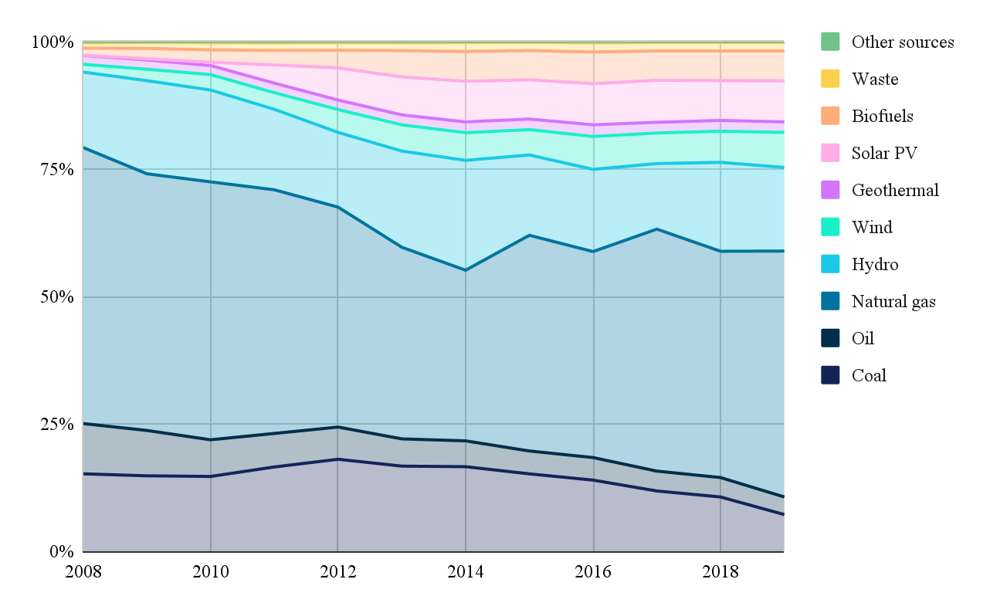
Figure 1. Electricity Generation. Italy (2008-2019)
Source: IEA Data Services

1.2.2.2 Total Final Consumption
The graph (fig. 2) represents the Italian consumption in millions TJ. There are no significant shifts in trends. The only considerable change is the gradual decline of oil products and coal consumption, which acquired a stable form in 2013. This is coupled with such trends as turn to electricity incorporation in the transport sector and shift to natural gas for economic and ecological considerations. Dominant resources over the analysed period remained same: electricity, natural gas and oil products. Contribution of renewables is less than million TJ but remains stable. The reasons are slow policy adoption and structural limitations as geographical constraints on hydropower. However, the stabilization of renewables consumption is a harbinger of long-term policy anchoring.
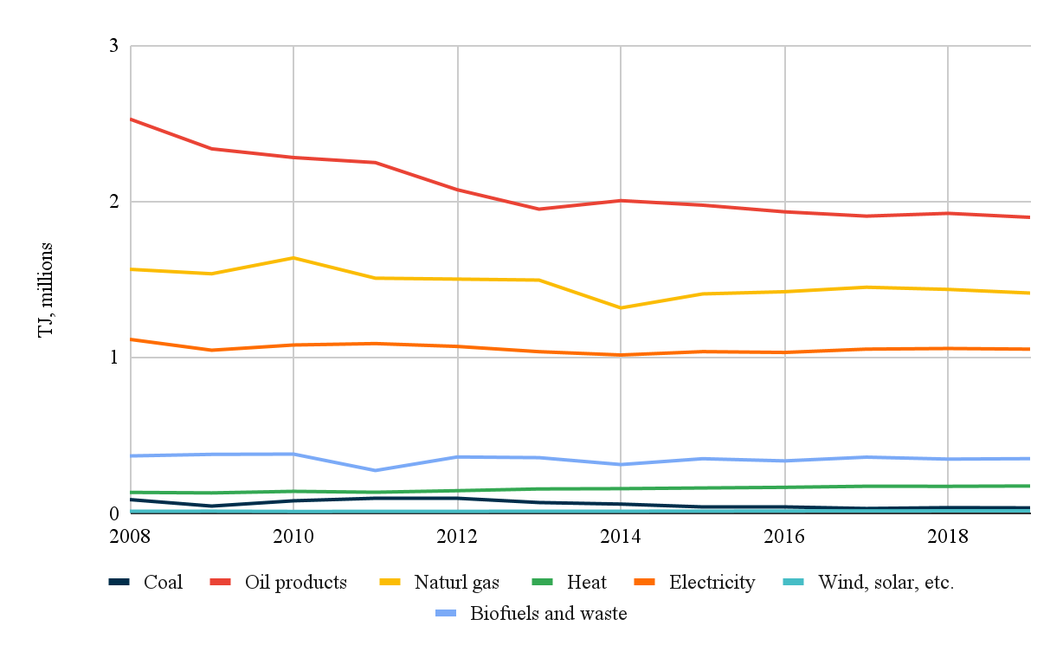
Figure 2. Total Final Consumption. Italy (2008-2019)
Source: IEA Data Services

1.2.2.3 Domestic Production
Assessing domestic production (fig. 3), it does not satisfy the consumption: while consumption is measured in millions TJ, production is measured in thousands TJ. The dynamics in production is notable. First, IEA Sources does not provide data on coal production after 2014, which indicates a notable reduction. The crude oil production has also decreased, reaching its bottom in 2016 with further slow recovery. Reasons behind it are both global and Italy-specific. In 2014-2016 the global oversupply, partly caused by the boom of U.S. shale production and slow demand growth, led to oil prices collapse. In 2016 market price on oil was below $30/barrel which may explain the drop in domestic production. As for domestic factors, they include environmental restrictions, putting constraints on exploration and production activities, and aging fields (e.g., Val d’Agri). Second, natural gas mining has declined since 2012, reaching the same point in 2018 as hydro. The decline in natural gas extraction mirrors reduced output from the Po Valley basin, which is Italy’s largest gas mining location (ENI, 2018). Third, the policy, focusing on renewables turned to be fruitful, as since 2012 the stable but gradual production growth continued. It is considered to be a fruit of changing incentives and subsidies cuts. Consequently, the solar boom was in 2011-2013.
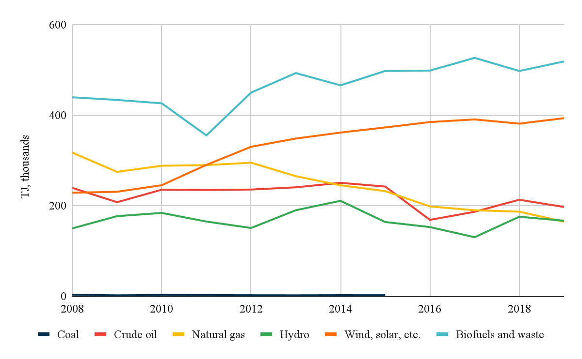Figure 3. Domestic Production in Italy (2008-2016)
Source: IEA Data Services

1.2.2.4 Total Energy Supply
The disproportion of national energy production and consumption shows Italy's inability to meet the energy needs, making it highly dependent on imports. Since 2014 there are no significant changes in distribution of importing resources (fig. 4). But in general, since 2008 the trend on gas import was a declining one and since 2014, after reaching its bottom, became stable. Described in numbers, from approximately 8 millions of TJ it decreased to 6 millions. Such reduction reflects economic stagnation, shifts in consumers’ patterns and other challenges following the 2008 crisis. The gradual normalization of gas imports after 2014 indicates the presence of structural import-dependency. Notably, the import of oil from 2008 to 2019 continued to decline, providing a greater ratio to natural gas. This can be explained by aligned with EU decarbonisation policy, clear nature of gas and, consequently, the increase of gas in power plants. The renewables share with time did not change fundamentally. This stagnation is driven by political, public and infrastructure rooted obstacles. First, Italy has one of the longest permitting times among Europe. Some wind projects are waiting 5 years for permission. This bureaucratic complexity alongside tariffs changes act as sources of uncertainty for investors, reducing investments in the field. Second, the public opposition (NIMBY) is scenic but potentially promising in RES regions (e.g., Sicily, Sardinia) is a barrier towards RES projects. Despite political orientation on clean energy, NIMBY attitude results in land-use restrictions further limiting suitable sites for renewables. Third, the grid ageing and lack of sufficient energy storage limits efficient use of excess solar and wind power. The geographic mismatch between north and south is also reflected in infrastructure issues.

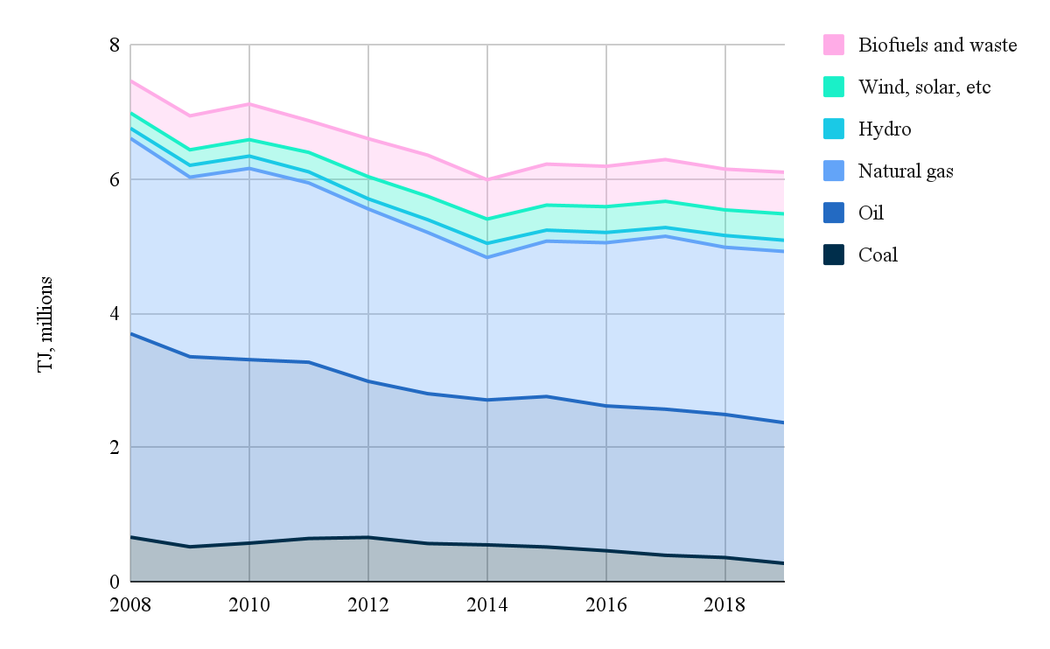Figure 4. Total Energy Supply. Italy (2008-2019)
Source: IEA Data Services

Chapter 2

2.1 ‘Delivering the European Green Deal’ as a shaping factor
The European Green Deal (EGD) was introduced in several phases. In order to get a general outline for deeper understanding of initial intent, the paper makes a short overview of the factsheet ‘The European Green Deal’ published in 2019. This provides an initial roadmap and political vision, designating goals with broad strokes. For the present, two more factsheets were published: ‘Communication & Roadmap on the European Green Deal’ in 2020 and ‘Delivering the European Green Deal’ in 2021. The factsheet of 2020 represents a modified version of the initial document, being a bridge from EGD to its legislative shape. It provides a legislative roadmap and broader policy linkage; still, it lacks exhaustive information on Member State obligations. So, the research uses ‘Delivering the European Green Deal’ documents. Inasmuch this version contains more specific information, its overview is useful for answering questions – namely, why the EGD is a challenge and what the obligations of the Member States are.

Ideological Background of European Green Deal
The acceptance of EGD reflected the EU strong commitment to goals declared by the Paris Agreement, adopted in 2015. The objective of the Paris Agreement (PA) was to respond to climate change in a coherent and collaborative manner. The allegiance to sustainable development is expressed in objectives and principles of PA. Parties agreed to facilitate the limit global temperature rise to well below 2°C above pre-industrial levels, pursuing efforts to limit the increase to 1.5°C. Another key target was to promote low greenhouse gas emissions development, achieving global peaking as soon as possible. In general goals come down to boosting resilience and increasing adaptive capability. Not only common goals united parties but also principles. The distinctive feature is that parties are presumed as equal, but responsibilities are differentiated with respective capabilities. To infer, the PA emphasizes climate justice and support for vulnerable regions.

The factsheet ‘The European Green Deal’ defines Green Deal as a new growth strategy. It should make Europe climate neutral, improve the well-being of people and preserve biodiversity. The EU countries agreed at adopting a number of measures in four areas to achieve targets. First, achieving climate neutrality by 2050 requires decarbonization of the energy sector. Second, policy on building renovation is supposed to accelerate the decline in energy bills and energy use. Third, modernization of the European industry sphere, which by 2019 used only 12% of recycled materials. Fourth, reduce emissions from transport, making it clear and affordable. The initial stage of EGD makes an emphasis on such measures as circular economy, promoting projects for greening economy and renewables offshoring. As for RES, the broad objectives and strategy were established. Increase of ocean energy capacity from 13 MW in 2019 to 40 GW in 2050. An increase of EU offshore wind energy capacity from 12 MW to 300 GW. Strategy underscores investments, regional cooperation, legislative frameworks, sustainable supply chains.
Moreover, the European Climate Law was introduced in 2020. It is a bridge from political promises to become climate neutral by 2050 to legally binding obligations. Still, its borders were streamlined. The notion declared the importance of the business environment, updating emissions reduction targets, regular reports, resource efficiency and assistance to vulnerable communities.
The program also took into account the social-economic costs followed by transition with which industries and people would face. It suggested a transitional mechanism, expressed in financial support, technical assistance and providing attractive conditions. Establishment of Just Transition Fund to assist industrial regions in transition correlates with PA climate justice.
To infer, the first stage of EGD indeed coincides with Paris Agreement targets. However, it is rather a political manifestation than a set of clear obligations carried by parties.

In order to trace how EGD has impacted the Italian energy policy it is necessary to answer the question: ‘Why is the European Green Deal a defiance for the economies of member states?’. This part of the chapter focuses on set objectives and requirements.
This version of EGD has come up with more narrow legislative frameworks with specific aims. The European Climate Law was replenished with the ‘Fit for 55 package’ and supported by a number of other initiatives. The idea behind it is to reduce EU net greenhouse gas emissions by at least 55% by 2030 (vs 1990 levels). Legislation package calls for all economic sectors to fit the target. The framework is composed of 12 multi-vector mechanisms representing steps for target achievement. Since this part of the research is interested in renewables, energy efficiency and energy saving, it is necessary to elaborate more specifically on precise mechanisms: Renewable Energy Directive (RED), Energy Efficiency Directive (EED) and Alternative Fuels Infrastructure Regulation (AFIR).
The first RED was adopted in 2009, setting a target for 20% renewables by 2020 and 10% for transport, promoting renewable fuels such as biofuels and (later) hydrogen. In 2018 REDII entered into force as a part of the ‘Clean energy for all Europeans package’ establishing a binding renewable energy benchmark 2030 of 32%. REDII the increase of RES share in gross final energy consumption spread to the sectors of electricity, heating and cooling, transport (2021-2030). Transport-specific target is 14% with sub-targets of 3.5% for advanced biofuels and 1% for renewable fuels of non-biological origin, such as hydrogen. Biofuels must achieve 65% GHG savings compared to fossil fuels. Heating and cooling are planned to be an indicative increase of 1.3% annually. Additionally, Member States must ensure a 3% annual renovation rate for publicly owned buildings. The frame as a whole was a strategic move to meet the Paris Agreement commitments and to sustain EU leading positions. However, under the ‘Fit for 55’ package (2023 revision (RED III)), this target was raised to 42.5%, further reinforced by the REPowerEU Plan, which aimed to reduce reliance on Russian fossil fuels and fast-track renewable deployment. Directive put new policies into place for different parts of the economy in order to assist countries in fitting the goal. Specifically, it pays attention to sectors, where the transition process has been protracted – heating and cooling, building and transport. By 2030 the share of RES in transport should reach 14%. Industry sector is required 1.6% of annual RES increase, while heating and cooling are supposed to rise to 0.8% annually in 2021-2025. The target of usage of RES in building energy is the highest to be achieved by 49% by 2023. For district heating and cooling, the target remains indicative (an annual average increase), reflecting flexibility due to varying national capacities. The strict policy should contribute to electrification, achieving the goal of the EU as a climate-neutral actor. The new binding targets for renewable fuels of non-biological origin set out by the regulation are aimed at these difficult-to-electrify sectors. RED III sets additional criteria for green hydrogen, requiring renewables-based hydrogen to count toward targets. In addition, granting procedures for RES projects and infrastructure needs to be made easier. All in all, the recast directive aims to create an effective and circular economy with renewables-based electrification and cross-sector focus.
The EED is a tool to decrease the overall EU energy consumption. It requires Member States to reduce primary and final energy consumption by 2030 and increase annual energy savings. Initial version of the EED of 2012 obliged all the EU states to show how they intended to achieve their 2020 energy efficiency targets and annually report on achievements. Its target was 20% efficiency improvement by 2020. After the first revision, in 2018, with the objective of 32,5% by 2030 and raised the annual energy savings obligation to 0.8% with transport inclusion (2021-2030), Cyprus and Malta are exceptions. In accordance with the legislature, Member States were obliged to develop National Energy and Climate Plans for a decade (NECPs). NECPs should contain strategies on how countries plan to achieve energy efficiency goals. The EED of 2018 focused on methods to improve energy efficiency with orientation in 2025. Among them is improvement of reliability and transparency of Energy Performance Certificates, installation of building automation and control systems. Enlargement of recharging infrastructure for EV with requirement to have minimum one charging point in renovating buildings with over 10 parking spaces. Improvement of technical building systems which would ensure a healthy indoor environment (ibid.). In 2021 commission proposed the recast as a part of ‘Fit for 55’ scheme. The ‘energy efficiency first’ principle was introduced as a core policy element, further fixed on the legislative (EU/2023/1791). The REPowerEU Plan further accelerated progress and in 2023 was published the reversed version of the directive (EU/2023/1791) which raised the EU bar of energy efficiency. New annual energy saving obligations are dubbed as an incentive for energy savings in end-use sectors (e.g., buildings, industry, heating/cooling): 1.3% of final energy consumption in 2024-2025; 1.5% in 2026-2027; 1.9% in 2028-2030. Revised EED introduced new measures such as requirements for NECPs; digitization and promotion of smart grids; support schemes for vulnerable consumers; sector specific measures. In this version transport occupies an official place, framed with alternative fuels, electrification.
The AFIR, initially introduced as a non-binding directive in 2014, was transformed into a binding EU regulation in 2024, with its roadmap first outlined in 2019. The European Commission website published three key objectives of AFIR. First, Member States have to ensure a baseline infrastructure for the mandatory transition to alternative fuel vehicles across all transport modes. It entails deployment of publicly accessible charging and refuelling stations (for electricity, hydrogen, methane, and shore-side electricity) along TEN-T networks and in urban nodes. Second, provide full infrastructure interoperability. In other words, make users’ experience compatible, seamless, and friendly. Third, provide citizens with transparent, complete, and easy access to information on the alternative fuel infrastructure and accessible payments. The AFIR provides more concrete targets, described in numbers in some points. By 2030 to build hydrogen refuelling stations every 200 km on the TEN-T core network. Moreover, there are requirements for EV charging stations, which must be within 3 km of TEN-T exits. The regulation differentiates charging between light- and heavy-duty vehicles. Both should be on every 60 km on the TEN-T core network. However, the capacities are different: ≥150 kW (fast-charging) for light-duty vehicles and ≥350 kW (ultra-fast) for heavy vehicles. The progressive deployment is planned from 2025 with full coverage by 2030. Another target is to create a shore-side electricity supply infrastructure in TEN-T maritime ports, which would contribute to zero-emission port operations.
These three mechanisms are interconnected. Thus, AFIR ensures the infrastructure for clean transport, facilitating RED’s renewable energy targets in transport. And vice versa, REDs’ promotion of renewable fuels makes AFIR’s infrastructure more sustainable. The EED, driving overall energy savings, supports both efficient transport and renewable adoption.
Italy, as an EU member nation, is directly affected by these ambitious goals and legislative changes. The country has special challenges of expanding renewable energy deployment, improving energy efficiency of its existing building stock, and EV infrastructure development. The government of Italy must ensure that its National Energy and Climate Plans align with these EU mandates and balance economic development with sustainability.

2.1.1 Italian measures to fit RED, EED and AFIR targets

2.1.1.1 Integrated National Energy and Climate Plan (INECP)
The Italian INECP was developed to meet the European Green Deal goals; however, it reflects national peculiarities (e.g., energy portfolio, structure, political priorities). It received final approval in 2020 and is currently under revision, in order to reflect the REDIII targets. The INECP is composed of the widest spectrum of instruments contributing both to national interests and common EU targets. The analysis looks at the Plan through three selected prisms, in order to narrow the study.

Assessing the INECP from the dimension of REDII, Italy’s national renewable energy target of 30% trails the EU-wide goal of 32% by 2030. Still, this benchmark has increased significantly from Italy’s 2020 target of 17%. The gap of 2 percentage points can be explained via feasibility and ambitions. Support charge on RES have skyrocketed from €3.5 billion in 2009 to €13.3 billion in 2017. This economic tendency provokes concerns about affordability for households and enterprises, instilling fear of energy poverty. This stems from the vulnerability of a large population share to rising energy costs. There are other factors that also impose restrictions. There is a paradox in the implementation of renewable energy plans due to environmental considerations. The need for infrastructure that is compatible with the landscape and protects biodiversity limits the large-scale deployment of renewable energy in sensitive areas. In addition, to make the transition smooth, projects such as one for coal phase-out workers were launched. In general, these circumstances can explain the gap of 2%. It somehow reflects Italian pragmatic and socially responsible approach in question of RES increase.
Moving to sector-specific targets, Italy sets a 22% RES share in transport (RES-T) by 2030 exceeding the EU’s 14% benchmark. The growth is supposed to be driven by providing economic and regulatory initiatives. Namely, incentives for biomethane and advanced biofuels; obligations for biofuels under RED II (alignment with AFIR); a 6% reduction in GHG emissions from fuels by 2020 and sustainability certification. The promotion of shift towards collective and smart transport and modal shifts to rail are crucial. As for investments, for vehicles investments had to increase from 732 (pre-NECP policy) to 759 € billion. It sets a target of 6 million EVs by 2030, representing 19% of the total vehicle fleet.
As for the heating and cooling sector (RES-H), national and supranational (REDII) targets for 2030 coincide. The NECP mentions measures such as Thermal Energy Account, grants for municipalities, and white certificates.
The national target for the electricity sector (RES-E) is 55% of RES share. Here the growth-oriented measures are multi-vector (e.g., policies such as exemptions from self-consumption charges for small plants, promotion of power purchase agreements (PPAs), competitive incentives for large RES plants, revision of the rules for granting, streamlining of authorisations, communities). The document makes an emphasis on the role of solar, wind and hydro energy. By 2023 the final gross electricity consumption from RES-E will achieve 38.7%. The growth is expected to be driven by hydro (51.0 TWh), solar (34.6 TWh) and wind (25.1 TWh).
Key incentive schemes for renewables increase remain the same as in previous years: feed-in tariffs, auctions and innovation programmes. Stimulation of distributed generation expansion, particularly rooftop solar. It builds Italian solar capacity simultaneously mitigating the problem of grid congestion. The document pays attention to the strategic importance of cooperation between companies Terna and Snam Rete Gas. It would make incorporation of RES in electricity and gas systems smoother and more effective, aligning with long-term NECP plans.

Analysing the INECP through EED licence, Italian national objective aimed at 43% reduction in primary energy consumption by 2030 (vs PRIMES 2007). This ambition in energy efficiency surpasses the EU’s bar for 32,5%. Switching to concrete numbers, the primary energy consumption is planned to be 126 Mtoe with final energy consumption 104 Mtoe by 2030. While in 2005 they made up 158 Mtoe and 133 Mtoe, respectively.
Italy also adopts the EU’s 0.8% annual savings obligation, the achievement of which is supported with wide policy measures with special attention to white certificates. It is exchangeable assets that attest to the fact that energy efficiency initiatives and interventions have reduced end-use energy consumption. The scheme also encourages the creation of initiatives that employ renewable energy sources for purposes other than electricity. This stimulates development and incentivizes energy efficiency projects across sectors. However, white certificates faced challenges in the face of market and regulation. Others are promotion of district heating/cooling; commitment to smart metering roll-out for both electricity and gas and consumer information.
The building sector's target was to renovate at least 3% of the total floor area, owned by the central government. The main project responsible for it is ‘Ecobonus’. The policy towards private buildings includes the continuation of the tax deductions. NRRP allocates €15.22 billion to the initiative, a fiscal mechanism offering 110% rebates for energy efficiency refurbishments in private buildings and social housing. The program targets seismic improvements, reflecting Italy’s dual priorities of energy efficiency and building safety. However, the Ecobonus has come under fire for encouraging fossil fuel technology and not necessarily reaching sufficient energy efficiency levels, which may be at odds with EED's decarbonisation objectives. In turn, the generous policy of 110% t is accused of higher-than-anticipated costs, straining public finances. The additional investments planned – €180 billion and €90 billion – for residential and tertiary sectors. It demonstrates the support for renovations and nearly zero-energy buildings (NZEB). Notable, that renovation process is expected to impact the employment rate: generation of 13,341 (tertiary) and 20,120 annual work units (AWU) (residential). This tendency highlights the economic potential of efficiency measures.
In transport, EED and RED II objectives align, focusing on reducing mobility demand, promoting collective transport via Urban Plans for Sustainable Mobility (PUMS), and improving vehicle efficiency through fleet renewal. Here the main challenge is consumer adoption.
In the industry sector the key policy tool aimed at adoption of energy management systems by companies via mandatory energy audits. Interestingly, that investment gap of 6 € billion (increase) is not so big, as in other sectors (current policy (2017-2013) vs NECP). Still, high upfront costs and coordination with local authorities require additional public finance to sustain progress.
The energy efficiency is also achieved via grid development, but it will be covered in part dedicated to AFIR.

As prior 2024 the requirements of AFIR were not clear, the evaluation via comparison with EU-wide goals is impossible.
Assessing the EV charging infrastructure, Italy has developed ‘National Plan for Electric Vehicle Charging Infrastructure’ updated in 2016. By 2020, the plan aimed to build 6,000 fast charging stations and up to 13,000 slow/accelerated charging stations. The is an exploration of vehicle-to-grid technology as a tool of integrating vehicles with the electricity grid. The NECP notes the wide program of RES-T plants installations which will increase employment rate.
The NRRP’s €3.61 billion investment in smart grids (aligns with EED) which increase the flexibility of the energy system. As for energy transmission infrastructure, which is the subject of AFIR, the paper focuses on the plans after 2019. Thus, by 2023 the implementation of three 380 kV electricity lines was planned: Colunga-Calenzano, Foggia-Villanova and Bisaccia-Deliceto. Within the period of 2018-2022 planned investment costs in the distribution network were €21.4 billions. In general, €4.11 billion (by 2030) for network infrastructure upgrades were planned, with specific focus on Adriatic coast: upgrading of at least 1000 MW of transmission capacity on the Adriatic coast; ‘Adriatic Spine’ project consisting of HVDC power lines. In a broader context, these investments are the part of wider initiative – investments in the National Transmission Grid. All these investments contribute to development of smart grids and training climate resilience. Thus, it facilitates the integration of renewable energy, making the grid more reliable. Improvement of grid capacity could handle increased electricity demand from EV charging and facilitate the integration of renewable energy sources. This is an indirect linkage between transmission grids and AFIR. The strong focus on the Adriatic region is conditioned by its strategy for electricity transmission due to its geographical position. Notably, the Adriatic coast is attractive for wind and solar projects deployment, which aligns with RED.
As for alternative fuel deployment, the document has a limited scope: it does not focus on alternative fuels for maritime or aviation sectors. However, it promotes the use of advanced biofuels in the transport sector, targeting 1.2% energy share by 2030. In addition, the NECP’s lacks focus on biofuels, biomethane and infrastructure for alternative fuels to be analysed through AFIR’s. Thus, it limited the analysis.

2.1.1.2 Italian National Recovery and Resiliency Plan (NRRP)
Another plan to be approached through the prism of three ‘Fit for 55’ mechanisms is NRRP, approved by EU Commision in 2021. It consists of a set of steps, developed in line with Next Generation EU initiative as a response to COVID-19. Despite the pandemic roots of the plan, it closely aligns with EGD. It is backed with ‘Do No Significant Harm’ principle, meaning implementation holistic and environmental approach in all reforms as investments. Most of the projects within NRRP should be completed by 2026. This plan is analysed in order to gain more information about Italian measures. Acknowledging its general fit with EGD targets, it focuses mostly on figures.

The Mission 2, Component 2 (M2C2) of NRRP is the primary section addressing renewable energy, aligning closely with RED. Within the frames of NRRP significant resources are allocated for facilitating the RES share in the Italian energy mix. Investments include €3.61 billion for renewable energy projects with specific focus on photovoltaic, onshore, and offshore wind energy. As a result of projects, approximately 2,300 MW of new renewable energy capacity are planned to be generated. This strictly goes in line with REDII’s target of the rise of RES ratio in electricity production. The focus is both on high potential off-shore technologies and experimental systems using wave motion. The projects are divided into off-shore (e.g., floating wind farms in Southern Italy) (€0.68 billion) and on-shore (€2.2 billion) types. All in all, these changes aimed to reshape the energy structure, making it more flexible. Moreover, the policy allocates €0.73 billion to support two thousand renewable energy communities. This would help to decrease the energy poverty, reducing energy costs for citizens and businesses. There are obstacles on the way of policy realization, however, they are planned to be tackled via reforms. Policy is directed at removal of administrative barriers and incentivisation private investment (PPAs) in renewables.
The document licence of RED allows the analysis sector beyond electricity from a limited perspective. As for the heating and cooling sector, its RED notion here is limited with main focus on efficiency. NRRP calls for fossil fuel-based heating systems replacement via adoption of heat pumps, solar thermal systems, and biomass-based heating in residential, commercial, and industrial sectors. As for transport, it is mentioned in the context of alternative fuels and charging infrastructure.

The implementation of EED is mainly monitored in the M2C3 section, which is dedicated to retrofitting buildings and improving energy performance. Three main objectives can be distinguished. First, annual reduction of energy consumption in all types of buildings by 0.4 Mtoe by 2026. Second, achievement of NZEB standards for retrofitted buildings. This would help to achieve the EGD long-term target for 2050. Third, follow the EED’s requirement for building renovation and energy saving goals. For achievement of goals allocated €15.36 billion, splitted between residential (€13.81 billion), public (€1.55 billion), industry and agriculture sectors (€0.5 billion). The renovation policy in residential buildings includes Ecobonus and Superbonus programs, which overlaps with INECP content and analysis, but here the data is more concrete. By 2026, 4 million residential units planned to be renovated. Energy efficiency is also planned to be achieved via installation of 1.5 million square meters of solar thermal panels and 100,000 heat pumps. Plans for the public sector include upgrading 195,000 square meters and making 12,000 buildings to fit NZEB standards. It should lead to further annual consumption reduction of 0.1 Mtoe. Even for today it is possible to evaluate intermediate success. By June of 2023 the complete renovation of 17 millions mq in earthquake-resistance work. The goal for by the end of 2025 is to renovate about 36 millions mq covering all types of buildings, which superpass previous steps significantly (ibid.). The achievement of this ambitious goal should result in primary energy savings of 40%. The hurdles are to be overcome via bureaucratic procedures simplification, Superbonus program extension, introduction of energy performance contract.
It is possible to pay attention to grid modernization within the AFIR framework. Here investments are broader – €3.61 billion for smart grid, including ‘Adriatic Spine’ HVDC line. Mainly, projects are aimed at improvement of transmission between north-south and east-west.

Unlike INECP, the NRRP pays much more attention to AFIR direct vectors, namely alternative fuels. Starting with charging networks, NRRP allocates €0.74 billions both for EV and hydrogen stations. The deployment of stations for heavy-duty vehicles and hydrogen-powered trains in number of 10 and 40 respectively. As a result, this infrastructure should enable 1,000 hydrogen-powered vehicles and 10 hydrogen trains by 2026. The largest part of investments is allocated for hard-to-abate sectors, such as steel, concrete, glass. Taking into account that Italy is one of largest producers of steel, the involvement of hydrogen in the sector should contribute significantly to decarbonisation. The attention to biomethane production has also increased. It is planned to produce 1.1 billion cubic meters of biomethane. The plan mentions a €1.92 billion budget for biomethane refuelling. The government implemented steps to facilitate biofuels integration. It is the development of a national hydrogen strategy aligned with and supporting IPCEI projects for hydrogen infrastructure. Indeed, the national hydrogen strategy was published. According to it, by 2030, hydrogen is targeted to account for 2% of Italy’s final energy demand; while in 2050 – about quarter. Compared with biofuels total ratio with 0.53% in 2007, it can be said that politics has become more confident. As a result, targets became more ambitious. Current ratio of hydrogen final consumption covers 1% of national demand. Thus, the established target seems to be achievable. Governments aim to stimulate green hydrogen production by installation of 5 GW of electrolyser capacity by 2030 (ibid.). Within the scope of the EU, the Italian landscape is favourable for green hydrogen. It is equipped with a gas transport network and promising RES production, allowing ‘power to gas’ technology. The development of this field has a long-term implementation. Italian geographical location united Europe and potential African and Middle Eastern partners. However, there are limitations in the absence of legislation which would regulate hydrogen production through electrolysis; lack of economic sustainability of incentive mechanisms.
As for the EV sector, the key objective is deployment of 7,500 fast-charging stations along highways and 13,755 in urban areas by 2026. This closely aligns with AFIR’s targets, making a report more beneficial in comparison with INECP. However, the main obstacle is the grid capacity constraints reinforced with regional differences. Northern regions are more resilient in terms of grid development, compared with the South. This issue can be mitigated with expansion of smart charging and energy storage systems. The development of capacities allowing to store energy for a long time has s strategic importance (e.g., ‘power to gas’) . It helps to balance supply-demand in peak seasons, contributing to energy sufficiency.

To sum up, the analysis of two plans – INECP and NRRP – have proved the Italian commitment to EGD in frames of RED, EDD and AFIR. The paragraph tried to extract from documents the data, suitable for three selected frames. The NRRP contains in-depth and clearly stated goals filling some gaps in INECP. It is especially applied to the policy framed in AFIR, which upon 2024 was under formulation. Thus, the national policy evaluated keeping up with EU plans. On average Italian national targets in renewable energy sources policy coincide with the EU, with some minor fluctuations. Moreover, the Italian measures prove that three selected mechanisms overlap, therefore, reinforcing green transition.
The analysis has also revealed the barriers on the green transition path. Many of them have ‘historical roots’. Meaning that they were preserved from the period of 2009-2016 (Chapter 1). In context of the ‘renewable’ bar that has been raised, it answers the question why EGD is a challenge. However, the Italian government implements policy to overcome socio-economic obstacles and minimize costs.
The commitment to energy transition corresponds to the nascent trend of decrease of oil and gas role in previous decades (fig.1, fig.3). The process of coal phase-out finds support in incentivizing alternative biofuels usage and increase of energy efficiency. In general, comparing current policy with one of previous decades, it has become more complex and developed, alongside raised ambition.
Starting with the 20th century, the growth of alternative biofuels began, driven by leading and rising economies, such as the US and Brazil. The European Union has also contributed to this growth (fig. 5). Thus, it is worth paying attention to Member States contribution and Italy's role, as it demonstrates strong commitment to biofuels integration.
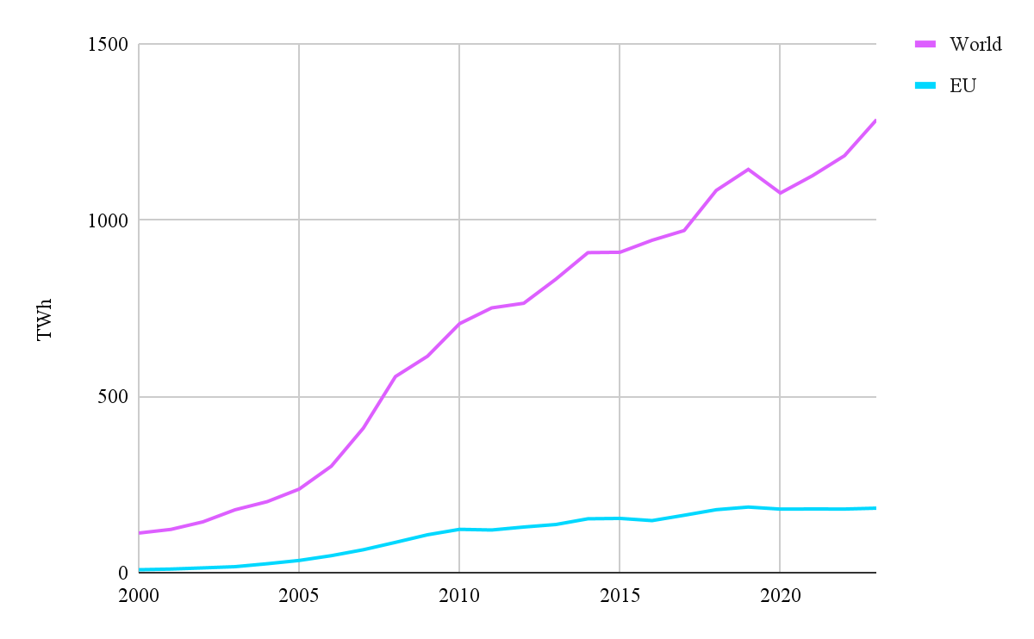
Figure 5. World Biofuels Production in Comparison with EU (2000-2023)
Source: Our World in Data

The graph (fig. 6) selected the most successful EU countries by 2023 and shows their biofuels production dynamics. According to it, Italy is not as big a producer as Germany; however, it is a country with sufficient biofuels production within the EU. It demonstrates a stable growth from 2013, while France and Spain experience a slowdown and Netherland’s growth is fluctuating. Focusing on the period from 2019, with EGD introduction, only Germany and Italy demonstrate growing tendency in the sector, despite pandemic and Ukraine crisis. Hence, the Italian government policy, described in expansion of hydrogen and biomethane, is indeed favourable. It does not result in some flashes of biofuels production; however, this stability can be interpreted as a policy on long-term oriented result. It is worth paying attention to the Biomethane plan of 2023 which aims to increase the biomethane output by 2.5 bcm. This coincides with post-2022 shifts in the energy market. Framing this objective within infrastructure capacities, Italy has an extensive framework of biogas plants (2 thousand), which integrates alternative fuel within the gas grid.
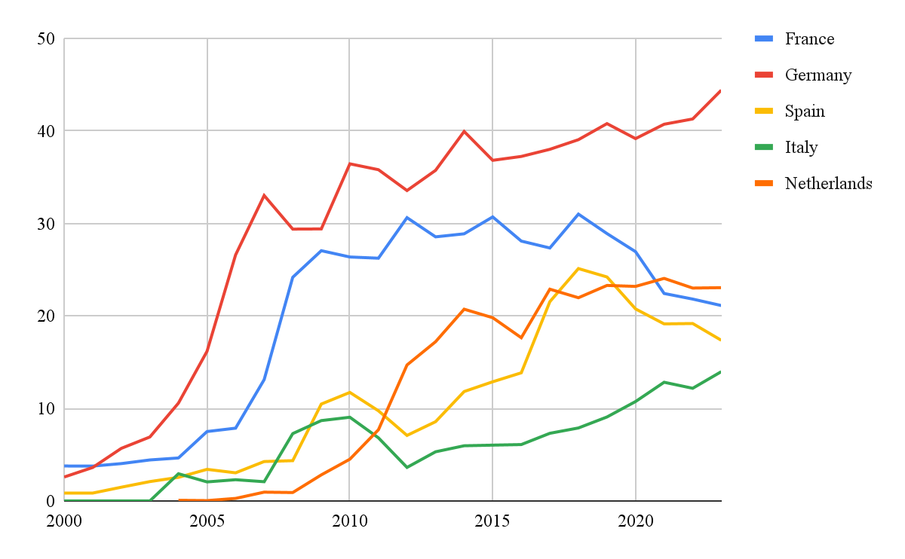
Figure 6. EU Members Biofuels Production (2000-2023)
Source: Our World in Data

Inasmuch reports focus on increasing the share of renewables in electricity generation, study compares Italian achievements 1) with leading EU economies (Germany, France) and 2) with countries with similar climate conditions (Spain, Portugal). The graph (fig. 7) shows the latest available data (2023).
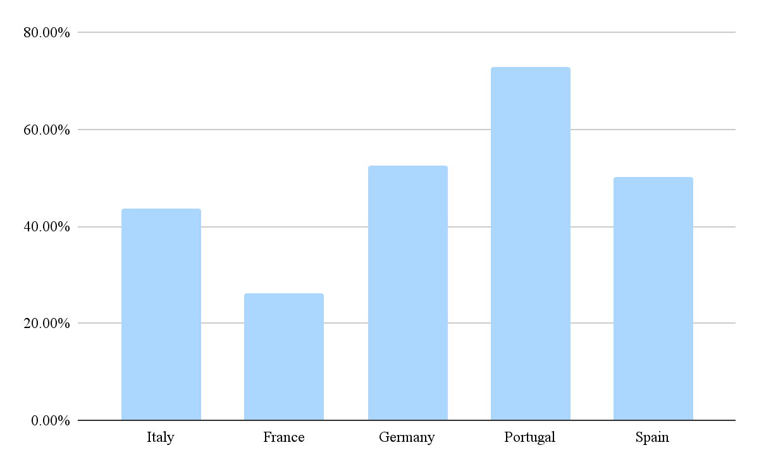
Figure 7. Share of Electricity Production from Renewables. Italy (2023)
Source: Our World in Data

Compared with leading economies, Italy is in the middle ground, between France with 26% ration of RES and Germany - 52%. However, focusing on Portugal, with the similar climate conditions to Italy, its performance is significantly better - 72%. While the value in Italy is 43%, it should be mentioned that in the previous 5 years, there were fluctuations, however, the general tendency was a rising one. The same observations are applicable to France, Germany, Portugal and Spain. Still, some of these countries have achieved greater results.

2.2 Sanctions as a shaping factor
Geopolitical tensions between Russia and Ukraine acquired an armed character in 2022, acting as another influential event on European economies. If EGD was a voluntary act, summoned to paint green economies, sanctions were voluntary-compulsory measures. It was in response to Special Military Operation and the countries' adherence to it simultaneously demonstrated their alignment with the UN and EU frameworks. Despite the economic interconnectedness between Russia and the EU, the destruction of which caused serious trials, condemnation was necessary. Italy, being highly dependent on Russian energy imports, has found itself in a complicated situation. Being an EU Member State, it was crucial to demonstrate dedication to democratic principles and solidarity with the EU. Still, Italian ambiguous attitude is reflected in its indecision in sanctions imposition.
Sanctions divided European countries in several camps. Italy is among ones who reluctantly agreed on economic sanctions. Moreover, across the EU it is a country with lowest level of support. Sanctions were a tool to inflict maximum damage on the Russian economy, minimizing consequences for European countries. According to European Council estimations, the value of withheld exports to Russia is €48 billion and €91.2 billion of withheld imports from Russia. The sanctions impact on the Italian economy can be divided into EU-side and Russian-side.
As for the first category, EU-side sanctions, the most hitted the economy hard was the six packages, which includes bans on oil and gas imports. Others are export bans on technologies and goods, accompanied by Italian port closures to Russian ships, and financial sanctions. Since the article analyses the economic side which covers counties’ energy mix balance, the attention is focused on Russian imports. The step of refusal from Russian imports was supported with the launchment of the REPowerEU plan, aiming to phase out Russian fossil fuels by 2027. With regard to the EU sanctions, the union has imposed an embargo on imports of Russian crude oil and petroleum products. The embargo came into effect in December 2022 for crude oil and February 2023 for petroleum products. On the eve of the war, in 2021, Russia was the biggest EU energy supplier, accounting for 25% of crude oil imports and about 40% of diesel imports. However, the embargo reshaped the EU oil market tremendously, resulting in less than 5% of Russian petroleum oils imports in Q4 2024 (ibid). International society implemented other measures to decrease Russian revenues from oil selling. In December 2022 G7 countries proclaimed a ceiling of $60/barrel price cap on Russian oil. Indeed, the demand on Russian oil dropped, accelerating with other events happening on the oil market.
Narrowing focus to the Italy case, only 11% of the overall demand for crude oil was satisfied by local production in 2021. Thus, as in previous decades, the country heavily relies on foreign imports. Despite the diversified oil import flows, Russia was a significant contributor. In 2021, crude oil suppliers from Azerbaijan accounted for 22% of total imports into Italy, making it the largest supplier, followed by Libya at 17%. Notably, even prior to the Russian - Ukraine conflict, its share of imports in Italy has been decreasing. While its peak was in 2013, accounting for 25% (330.11 kb/d), in 2021 it was 12% (ibid.). The graph below (fig.8) represents Italian major suppliers and how their share changed. Thus, within the last decade the origins of crude oil were diversified, covering African, Middle Eastern and Eurasian suppliers. The share of Russian supplies was fluctuating with an overall decreasing tendency, reaching 144.98 kb/d in 2020. Moreover, the data shows that the value of import was decreasing. It correlates with the decreasing tendency in oil final consumption and domestic production (fig.2, fig.3). Thus, indeed, oil's role in the energy mix declines in value. Still, it has a place and ways of Russian supplies replacement should be studied.
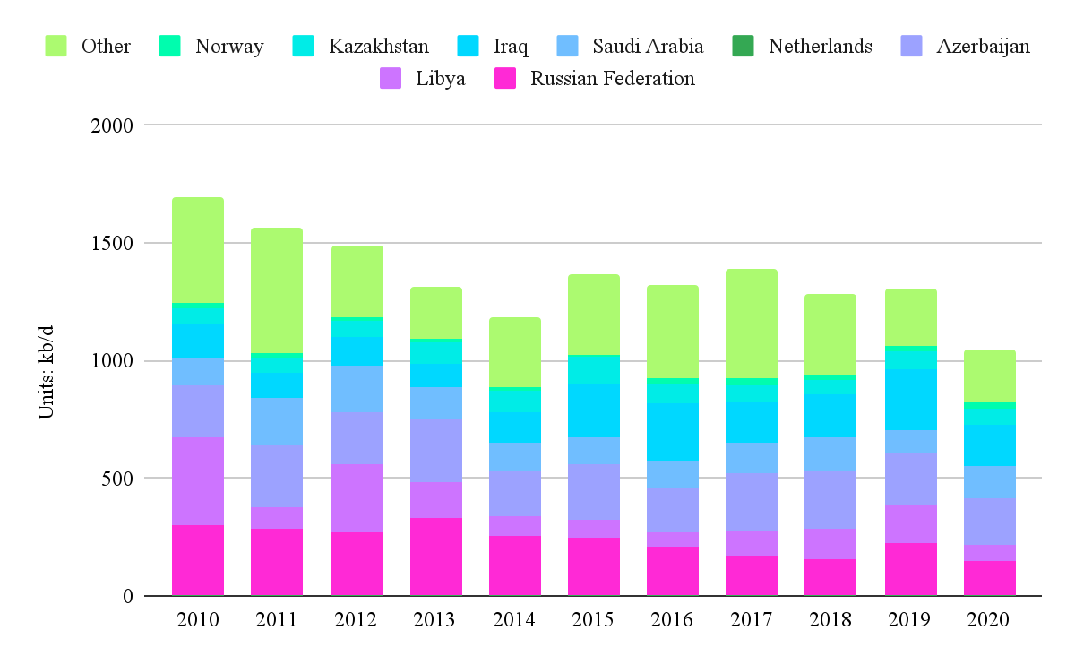
Figure 8. Crude oil net imports. Italy (2010-2020)
Source: IEA. Licence: CC BY 4.0

Notably, in many EU states the sources of gas supplies were not as diversified as oil. It was the reason why the European Union avoided outright sanctions on Russian pipeline gas. Thus, in order to not hurt itself, the EU excluded gas from the sanctions scope.

Analysing the Russian-side impact, its character was less structured; however, influential one. To start with, the Russian response on Western sanctions was the requirement to pay for gas in rubles. This policy was supposed to support Russian currency. However, some European states (e.g., Poland, Finland) refused to follow these requirements. In these circumstances Russia used its energy influence as an economic tool against Europe, suspending gas flows through its pipelines (Yamal, Gryazovets-Vyborg). Italy did not suffer economically, as it received gas via TurkStream and Ukraine transit, which continued operating. Despite the absence of direct impact in the Italian landscape, it sowed the seeds of anxiety. On 2nd September, 2022, the Russian government resorted to its energy weapon as a response to Western actions, including ceiling price on oil. Hence Gazprom announced that the operation of Nord Stream 1 is suspended due to technical issues. Notably, suspension of gas supplies via this pipeline was highlighted as indefinite. Narrowing focus to Italy, again, as Nord Stream did not supply gas to Italy, it was not affected. However, the influence of the event on the gas market still was felt, expressing exacerbated supply shortages and price volatility. The suspension of Nord Stream 1 entailed the broader decline in Russian gas flows through other routes that supply Italy, such as via Ukraine and TurkStream. Moreover, the overall reduction of gas in the European market resulted not only in increased uncertainty but also in increased gas prices. Thus, in Mart 2021 natural gas price in Europe was $6.13 and increased fast enough, compared with previous years of price stability. In August 2022 the value has reached a historical record – $70.04. This trend was preceded by the Nord Stream pipelines sabotage, which turned the page in European energy structure. In general, prices on fossil fuels continued to skyrocket. Comparing January 2022 and January 2023, consumer prices increased by approximately 11%. This diversion marked up tighter supply conditions going into winter 2022-2023 and beyond, despite having gas storages. Thus, many European countries were forced to reapproach their energy portfolios.
It should be mentioned that many European states had long-term gas contracts with Russia. Italy is not an expectation. Historically, from its conclusion in the 1960s Italy prolonged contracts with Russia multiple times. The most recent one in 2006 not only brought the Eni-Gazprom cooperation into a new strategic level, but also prolonged the gas-supply contract up to 2035. According to this contract, Eni became the biggest Gazprom client, buying over 28 bcm annually. Even so regional tensions did not lead to termination of the contract, the circumstances changed tremendously. First, in almost all the contracts that are valid until 2030-2035, Gazprom does not supply or no longer performs supplies, including with Italy. So, the country had to look for alternative ways to replenish the energy balance. Second, the major route for Russian gas to Europe – Ukraine transit – was closed in 2025. The reason behind it is the expiration of a five-year transit agreement. Even so the research does not cover 2025, this fact highlights the strategic importance of Italian diversification policy.

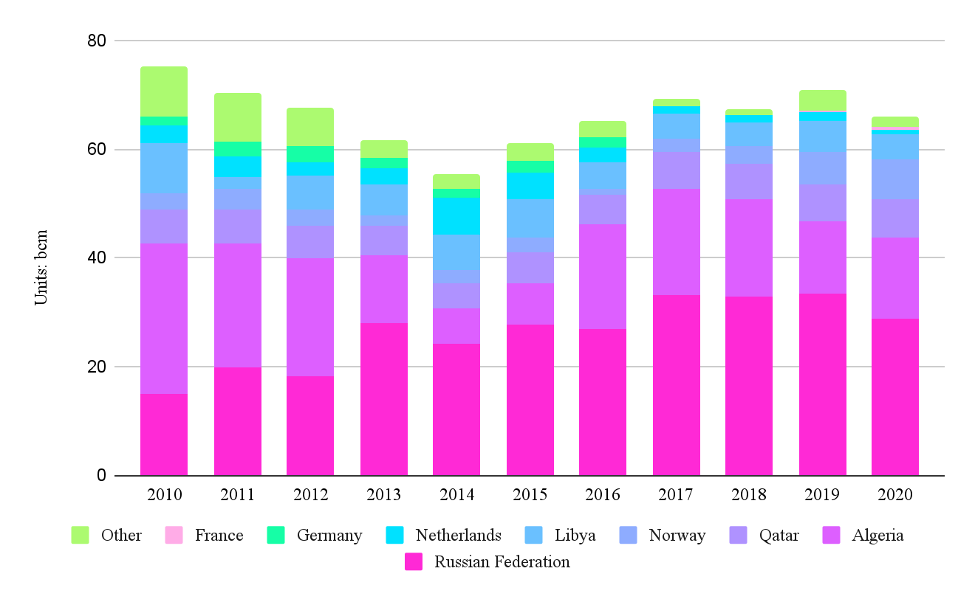
Figure 9. Natural gas net imports. Italy (2010-2020)
Source: IEA. Licence: CC BY 4.0

According to IEA data (fig. 9), Italian imports do not have a decreasing tendency, as oil imports. It demonstrates the crucial demand for natural gas and its stable position in the county energy portfolio. Within the last decade Italy had several natural gas suppliers. However, the diversification was not really strong. The biggest share was for Russia, especially starting with 2013. The second largest importer was Algeria. This historical trend is preserved up to 2020. Thus, in 2020 imports of both countries accounted for about 66% of total imports, with Russian 28.72 bcm and Algerian 15.12 bcm. As the clan data on Italian natural gas importers beyond 2020 is missing, the paper uses IEA (2023) report to get data for 2021. It highlights the total growth of imports at the expense of Azerbaijan gas, which accounted for 10%. The share of Russian gas did not change. The appearance of Azerbaijan as a supplier is linked with the launchment of Trans Adriatic Pipeline (TAP), deliveries for which have started on December 31, 2020. This infrastructural novelty granted Italy a new strategic importance, making it an entry point for Caspian gas into the EU. In addition to the presence of Italian landscape rich fossil fuels infrastructure, TAP contributes to assisting gas flows not only for domestic markets but also for Europeans. This diversification root is one of the reasons why it has received the honored status of gas hub.

2.2.1 Italian Response to post-2022 Energy Market Changes
The analysis on Italian response focuses mainly on fossil fuels politics, out of the RePowerEU scope. The section covers fossil fuels diversification, infrastructure creation and Plan Mattei, partially touching renewables.

2.2.1.1 Import Diversification & Infrastructure
Prior analysis, the current situation of Italy's energy market should be described. Italy abolished its ‘protected market’ policy for gas in 2024. As a result, the authority no longer regulates the gas supply; instead, market laws now govern it exclusively, and provider competition determines contracts and prices. The electricity market is currently undergoing the final stages of liberalization. The Single National Price (PUN) system is being phased out by 2025, to be replaced by a system of zonal pricing, in line with European regulations to promote greater market integration and competition. The regulatory framework, known as the TIDE, is modernizing the electricity market, eliminating obstacles for new participants, and fostering the integration of renewable energy sources. These changes create a more competitive landscape and enable the emergence of innovative market models.

In the last 5 years, overall, natural gas and oil dominate Italy's energy supply, though both show a gradual decline by 2023 (fig. 10). Renewable sources contribute less but remain stable, with wind and solar showing modest growth. Notably, in 2023 both oil and gas have converged. That is why the processes in oil and gas fiends happening behind the graph should be analysed.

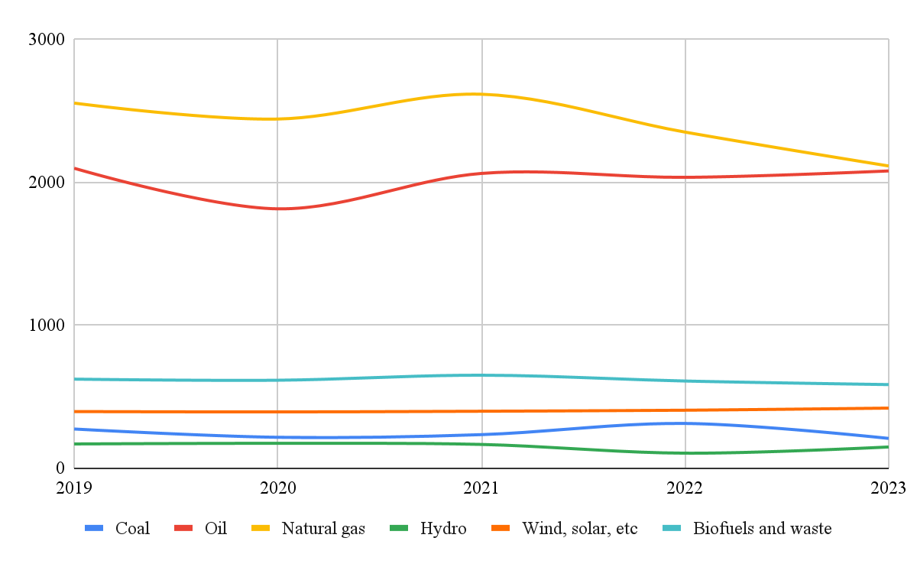
Figure 10. Total energy supply. Italy. (2019-2023)
Source: IEA. Licence: CC BY 4.0

Italy, being tied to Russian energy suppliers, faced the necessity to diversify energy suppliers. In 2022 the Italian national energy demand and consumption have decreased by 4.5% and 3.7%, respectively. As it was observed in the previous chapter, natural gas occupies a special position in Italian energy balance. Russian gas supplies have fallen from 38.2% in 2021 to 15% in 2023. Since Algeria for years was the second largest gas importer to Italy, with 2022 its importance has multiplied. Even in the previous two years Algerian imports have increased in share - from 22% (15.12 bcm) in 2020 to 34% in 2021.
In 2022 Eni and an Algerian company SONATRACH signed a long-term agreement on gas supply. It is a $4 billion gas contract which is supposed to increase gas volumes by additional 9bcm via the TransMed pipeline. Additionally, in 2023 parties signed an agreement for the study and construction of the Gasdotto Algeria Sardegna Italia (GALSI) pipeline construction, costing $2.5 billion. The network is planned to be multi-functional, being a gas pipeline, it will be used for ammonia, electricity and hydrogen transportation. GALSI is expected to connect Algeria and Piombo through Sardinia via underwater pipeline. Its construction is to begin in 2026 and finish in 2030. This project can significantly increase Algerian export to Italy and further to Europe. This part of the strategic partnership again highlights Italian energy transit status for the EU.
Assessing Libyan export contribution, there was a drop in gas flows from 3.2 bcm in 2021 to 2.6 bcm in 2022. In 2023, a gas deal for 40 years was signed between Eni and the Libyan National Oil Corporation. The price of the agreement exceeds twice that of the Algerian contract and amounts to $8 billion. Within its framework, substantial investments in Libyan infrastructure will be made. First, it includes the beginning of two offshore gas fields in 2026. Second, construction of a carbon capture and storage should be constructed to ally with the decarbonization trend, reducing carbon footprint. These actions will increase Libyan gas production up to 800 million cubic feet of gas per day, which decreased in 2011. The agreement allows Eni to recover its investment by keeping 38% of the retrieved volumes for the first 15 years. These supplies diversify the Italian energy portfolio for a long-term period. Currently, Libya is a small but stable Italian supplier.
On the eve of the Russia-Ukraine conflict Italy has successfully launched gas-relations with Azerbaijan. It has made Azerbaijan the second largest gas supplier in 2024, with approximately 16% share. More specifically, in the first 10 months of 2024, Italy imported about 7.98 bcm, which is a 3.6% increase compared to the same period in 2023. Notably, in 2024 among all European countries, Italy became the largest Azerbaijan gas buyer receiving around 20% azeri gas production. Over the TAP operation period, the supply fluctuations were 10-20 bcm. Hence, Snam investments (20%) in TAP construction have been paid with energy security coins in time.

The geopolitical shifts and pipeline sabotage created circumstances when European countries have to increase LNG imports. The role of LNG on the European market is a contradictory one. While the EU makes huge investments in greening the economy, the LNG consumption does not fit in the green agenda. The issue behind is that the process of LNG production harms the environment. Reorganization of the European energy market compelled states to resort to increasing imports. It results in a paradox between commitment to long-term decarbonization process and short-term LNG solution.
While the European average US is the biggest LNG supplier, followed by Qatar and Russia (2021-2024), Italian trends are slightly different.
By 2024 Italian LNG imports made up 11% of Europe's, placing it in 4th place (IEEFA, 2025). The table 1 below demonstrates that Qatar preserved its leading positions as an Italian LNG supplier. Even prior 2022 Qatar LNG accounted for 63% of total LNG imports. However, in 2022 the US occupied a confident second place, shifting Algeria. In 2024 the US will boost supplies five times, compared with 2021. Within the observed period the Italian total LNG consumption has risen by 30%.

Table 1
Italian Imports of LNG. Units: bcm (2021-2024)
 | 2021 | 2022 | 2023 | 2024
Qatar | 6.34 | 6.31 | 6.51 | 6.47
Algeria | 1.25 | 1.48 | 2.38 | 1.85
US | 0.93 | 3.12 | 5.43 | 5.02
Egypt | 0.26 | 0.70 | 0.31 | 0.08
Nigeria | 0.25 | 0.15 | 0.30 | 0.00
Trinidad and Tobago | 0.14 | 0.33 | 0.00 | 0.22
Spain | 0.11 | 0.88 | 0.85 | 0.20
Equatorial Guinea | 0.10 | 0.38 | 0.00 | 0.00
Angola | 0.09 | 0.09 | 0.00 | 0.28
Oman | 0.09 | 0.09 | 0.00 | 0.00
Norway | 0.08 | 0.08 | 0.00 | 0.00
Belgium | 0.01 | 0.01 | 0.01 | 0.00
Russia | 0.00 | 0.19 | 0.09 | 0.09
others | 0.30 | 0.01 | 0.64 | 0.19
Total | 9.95 | 13.82 | 16.52 | 14.40

Source: IEEFA, 2025

In 2015 Zohr, a scaled gas field, was discovered. This event reopened Egypt as a player in the world gas market. In 2018 Egypt exports exceeded imports, transforming the country back into a net exporter after 5-year vice versa dynamics. Italy occupies a special position for Egypt, being the main destination of its gas. But also, Eni possesses a stake in Egypt’s LNG terminal and is present on its three gas fields. In 2022 parties deepened their relations, signing a deal. It is aimed to increase Egypt's LNG supplies to Europe. As table 1 shows, its exports have a decreasing tendency and it is applicable generally to Egypt exports. It has roots in fall in domestic production and regional Israel-Palestine conflict, impacting the Egyptian market. Moreover, in 2025 Cyprus, Egypt and Eni agreed on development of the Cronos gas discovery and itf further supply roots. The basin was appraised in 2024 but Italy did not hesitate to use the opportunity.
Another Italian partner is the Republic of Congo. Signing agreement in 2022 countries agreed to increase liquified natural gas (LNG) imports. This agreement goes beyond and covers the construction of LNG-related infrastructure. It includes two floating LNG plants; operation was targeted in 2024 and 2025. As a result, the Republic of Congo began LNG exports to Italy in February 2024 in volume of 1 bcm. However, the volumes are expected to boost to 4.5 bcm per year with the construction of a second FLNG.
Eni also invests in Mozambique to make gas flows more diversified with time. As for the future, in 2025 was approved companies’ second FLNG project – Cabo Delgado – which should begin its operation in 2028. The project is located in the Rovuma gas basin, which is among the largest in the world. Regional instability has already influenced the process. In 2021 due to terrorist attacks one of three basin projects, led by France, was suspended; by now the construction was resumed. Still, Mozambique is a promising LNG actor on the trade arena. Currently releasing projects are expected to significantly increase exports by 2029. Among other projects, Eni development of gas fields in Indonesia. Despite its small overall exports, Italy invests in energy cooperation with Indonesia, focusing on expanding production and decarbonization.

To expand the vision of Italian fossil-fuel policy in recent years, the expansion of its transit network should be touched. The Poseidon Gas Pipeline, a project proposed in 2022, aimed to connect Greece and Italy. It should be a continuation of the Eastmed pipeline (supplies from Israel), being the deepest subsea pipeline in the world. Although the war in Gaza turned into a reason for temporary suspension. Moreover, Turkey on which the Trans-Anatolian pipeline is, does not support the initiative, fearing competition. The Poseidon realisation, indeed, can escalate the already difficult situation in the Middle East. Thus, the realisation of ambitious projects remains under the risks remaining on paper.
Within national territories Italy seeks to put an end to Malta’s energy isolation, building Malta-Italy Gas Pipeline and connecting Malta to the mainland gas network. It was designed under PCI in 2013, however the statutory permitting procedure in Italy was passed only in 2021. Due to bureaucratic barriers the start of pipeline construction is scheduled for 2028. Despite prolonged preparatory work, the project for Malta is more advanced and realizable than the Poseidon initiative.

As for oil, from 2019 to 2023 consumption was fluctuating, experiencing a significant decline during pandemic (fig. 12). However, in 2023 the trend has stabilised closer to the levels of 2019. The forecasted data on 2024 preserves this trend. The absence of decline in the post-2022 period proves fruitful diversification policy.

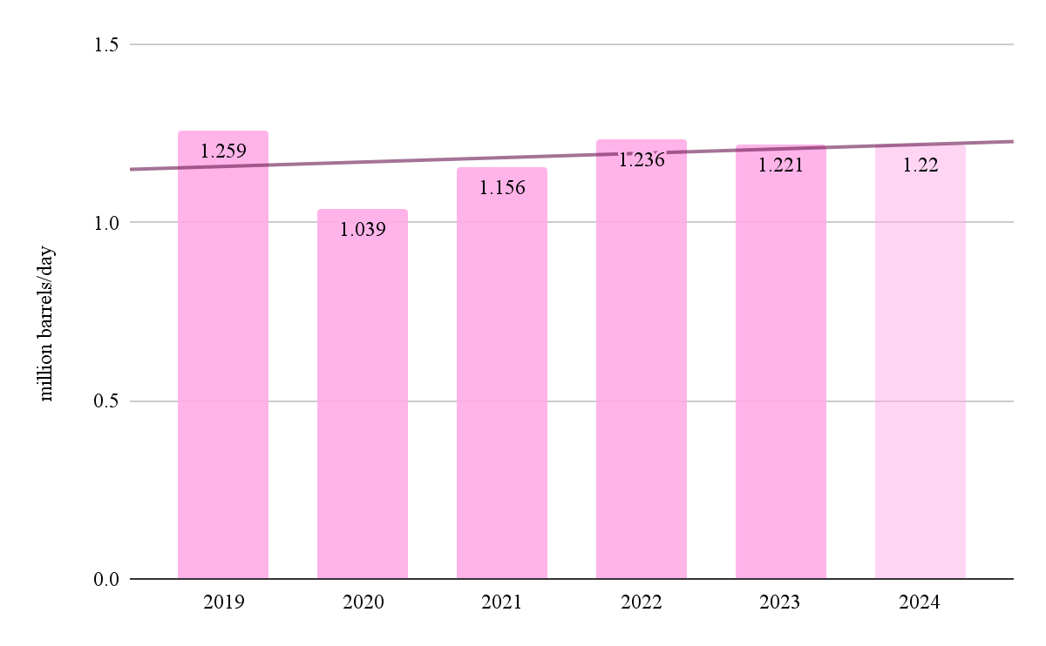
Figure 11. Imports of oil. Italy. Units: million barrels/day (2019-2024)
Source: CEIC Data

The oil balance was refunded at the expense of stable volumes of Azerbaijan's oil, which became Italy's major supplier after 2022 (fig.13). In 2023 Kazakhstan boosted exports from 6.7% in 2020 to 10.6% of Italy's crude oil imports. The United States accounted for a 12.3% ratio, placing at the third position. The appearance of this actor is the most notable change on the Italian oil market from 2022.

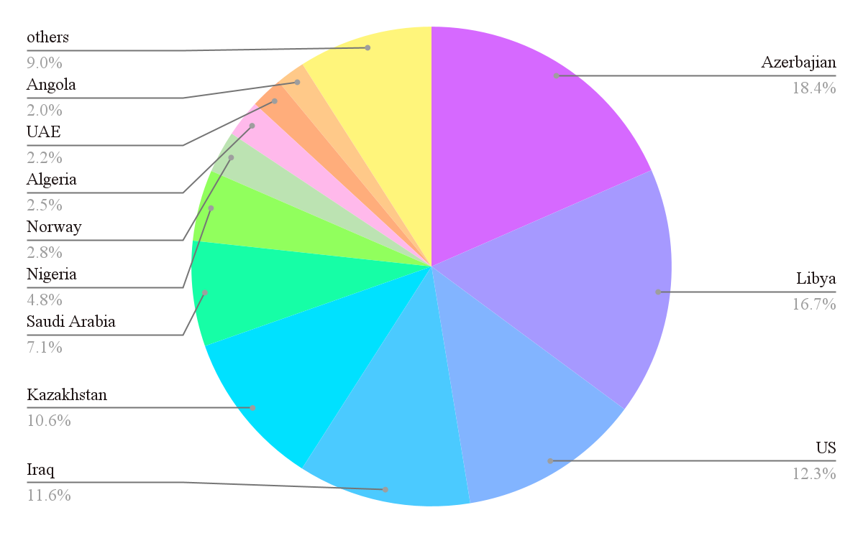
Figure 12. Imports of oil in 1,000 tons. Italy (2023)
Source: Statista

As for oil infrastructure, the policy is less broad. The biggest Eni-headed project is the conversion of Livorno refinery into a bio-refinery, announced in 2022. The Gela refinery case in 2019 created the precedent for Livorno. Livorno traditional crude refining has been suspended since early 2024. It is symbolic, taking into account decreasing oil share in the last decade in conjugation with the green agenda. Under the initiative will be constructed three facilities up to 2029 including plant producing hydrogenated biofuels and hydrogen production facility from methane gas. Same policy on increasing biofuel processing is planned to be done in Porto Marghera refinery, starting in 2025. Also, other refiners have to pass maintenance in 2025 (e.g., Iplom Busalla). Hence, infrastructure is serviced and passes green-transformation. However, no oil plant expansion in classical understanding is planned. Italy continues to implement phase out goes, simultaneously incorporating mechanisms of ‘Fit for 55’.

New geoeconomics circumstances have more firmly rooted in the idea than abolishment of nuclear power plants made Italy vulnerable. The encounter with new realities has proven that despite wide energy diversification policy, Italy remains dependent on an external unpredictable environment. This fact is reinforced with the inevitable skyrocket of electricity demand, which is expected to be doubled up to 583 Twh by 2050. Meeting such demand with reliance on renewables capacity is unthinkable and unworkable. The updated PNIEC (2024) provides Italy with recommendations to go back to the nuclear program deployment with thermonuclear fusion. Ideally, in 2050 it should cover 11% - 22% of domestic energy demand by 2050. In spite of decades of Italian an unambiguous negative attitude towards nuclear energy, these recommendations were not left on paper. In the same year, the government held a meeting with both foreign and national companies on the topic of deployment of nuclear reactors in the country. The step towards nuclear power was partially fixed on the legislative level. In March 2025 Italy’s Council of Ministers approved a draft law. It invokes the government to develop a legal framework, which would regulate nuclear production. Including plant construction with consideration of population security. Some concrete actions are already in the way of realization. Country plans to make investments of €200 million in New Cleo, a project for SMRs development. Supportive actions towards innovative nuclear technologie are traced in intention to establish the Nuclear Safety Authority. Within this framework, construction of new sustainable nuclear power plants by 2027 which would meet European and international standards in the industry are planned. It also implies dismantling of obsolete installations and implementation of safe solutions for nuclear waste storage and treatment.
The integration of nuclear power in the energy mix has a dual character. On the one hand, it aligns with EU decarbonization goals, being a cler type of energy production. On the other hand, it is an attempt to take a sip of energy independence. In addition to these factors, the cheap nature of nuclear energy counterbalances its danger. In contemporary circumstances when energy for Italy became costly, it is an attractive alternative to ensure sustainable and clean energy supply to the country. Still, it is difficult to forecast whether nuclear politics will take root. Especially taking into account historically lacking mass support, caused by a series of disasters.

To infer, the Italian strategic pivot to diversify its energy suppliers post-2022, driven by reduced Russian gas imports, has reshaped its gas and pipeline landscape. Despite LNG dual nature, it became the main substitution of Russian gas. State reacted operatively, launching long-term agreements on trade and investing in different sources of infrastructure. Many projects have started recently or are on plannery stage. This proves countries commitment to furthers securitizing via diversification. However, the instability in partners’ regions looming threat to reliability. As for oil-side, 2022 followed by importers shuffling, changing the ratio of each. In general, the gas diversification strategies are more urgent, while policy on oil is a moderate one. This trend is justified with the different role of both fossil fuels in the energy mix. Additionally, overlap of the new energy market realities and EU green goals turned into thaw of nuclear resilience. All in all, despite the fact of Italy's energy diversification in the past decade, new circumstances required new solutions.

2.2.1.2 Plan Mattei
The Plan Mattei was officially announced recently, in January 2024 at the Italy-Africa Summit in Rome. Prior to plan launchment, the Italian Prime Minister - Giorgia Meloni - made a number of visits to African countries (Mozambique, Algeria, Libya).
However, ideologically this strategy has its deep historical roots. The plan bears the name of Enrico Mattei, a founder of an Italian oil-gas company. The company played a key role in reshaping national energy policy. In contrast to the approaches of other oil-importing nations, Italy was able to propose a policy based on closer collaboration with oil-producing nations at the proposal of Eni, which was headed by Enrico Mattei. He strongly believed that Italy should use its geographical location and ensure independent energy supplies from nearby African and Middle East countries. These ambitions were paired with the necessity to break free from dependence on Anglo-American oil giants in the face of ‘Seven Sisters’. One of the first steps was Eni's successful breakthrough into Iranian oil fields. This caused discontent among major oil companies; however, via negotiations with Shah, Enrico managed to get a concession. This led to a number of permissions on field development concessions in other producing countries. Mattei also succeeded in pioneering gas imports from the USSR and Algeria. The continuation of this policy finds a reflection in current Italian energy imports. Thus, the personality of Enrico Mattei laid the foundation for current Italian energy politics, making Eni a symbol of national energy diplomacy.
Today the Enrico Mattei legacy is fixed by ‘Piano Mattei’, which makes Italy as a bridge between Europe and Africa. It describes Italy as a potentially promising country and Africa as a resource-rich region. According to UNEP (2025), the lands of Africa are hidden beneath 30% of the world’s mineral reserves, 8% of natural gas and 12% of oil. Both Italy and Africa are facing challenges. Establishment of a new model of equal partnership between them could help to overcome obstacles. The plan is a multidimensional one, covering cooperation in numerous fields from culture and education to energy and innovation. This complex approach to take African-Italian relations to a new level, addressing migration issues via economic development, makes the plan a strategic one. Still, despite numerous aspects, research focuses on the energy dimension.
In the light of reduction of Russian gas supplies, the cooperation with Africa acquired a new urgent round. The rhetoric of the plan supported the overall recent Italian energy diversification policy. Moreover, Italy seeks to use its Mediterranean location to create mutually beneficial resilient energy supply chains.
To begin with, as Piano Mattei (2024) states, Africa is a key fossil fuels supplier to Italy, with rising flows of renewables feedstocks. Since Italy has entered a decarbonisation era, priority is given to low-emission resources. Here natural gas is a bridge to the transition to a green economy. In this light, there are two key projects. First, it is the Eni-owned Trans-Mediterranean Pipeline, supplying 33 bcm of natural gas from Algeria annually. Second, the recent tripartite agreement signed in 2022 with the Republic of Congo, ensures annual supplies in size of 4.5 bcm up to 2026. This agreement was a part of Italian urgent strategy on import diversification with the beginning of the Ukraine crisis.
Second, the document contains information on plans regarding energy infrastructure creation. Particularly, the great emphasis is on networks for renewables. Algeria is a promising partner not only in natural gas, but also in the renewable sector. This fact grants Algeria with dual strategic importance. Thus, Italy participates in the development of South2Corridor under REPowerEU. The hydrogen should be supplied from Tunisia, via Agria, to Italy and subsequently distributed across Europe. Moreover, the use of North Africa's abundant renewable energy resources for the production of competitive hydrogen. The project is ambitious; however, it is still in the planning stage. Another project linking Italy with Africa is the ELMED, a fruit of cooperation between Trena and STEG. It is the first to construct a high-voltage electricity grid between Tunis and Italy. The project launchment was announced in 2019 and is planned to be finished by 2027-2028. Currently it is in the phase of laying submarine cables. The grid development is a part of a broader EU initiative – Project of Common Interest. ELMED remains the first project outside the EU, covering Tunis. In general, this grid enhances renewable energy trade and grid stability. Notably, the development of both infrastructure corridors demonstrates the commitment to green transition. The frameworks above – AFIR, EED, RED – are also applicable in this context. Additionally, the document emphasises the programs on upgrading transmission and distribution networks across Africa, including mini-grids. This is a declaration of commitment to grid infrastructure that complements specific projects like ELMED and SoutH2 Corridor.
There are also a number of projects which do not directly link the African continent with Italy. However, their development contributed to overall renewable grid sustainability. In Kenya Agri-Hubs for biofuels are under Eni construction, being a part of energy infrastructure, supporting Italy’s decarbonisation policy. Taking into account plans for 2027 on vegetable oils production, it promoted food security. As a consequence, these hubs complete the picture, supporting renewable energy feedstock supply chains. Another project is the Center of Excellence in Morocco, supported by the EU. Italian plans cover Morocco as a partner for energy diversification. While it is not a directly infrastructural one, it trains professionals for grid and technology management; optimize electrolysis.
Hence, the fossil-fuels and infrastructural scopes of the plan are limited. However, it provides the Italian views on Africa as a long-term partner. It is applied not only to ‘classical’ resources but also to a modern green energy phase. The fruits of the plan are to shift the centre of energy gravity towards the Mediterranean, making Italy a gas distributor. In long-term perspectives Italy may use the combination of its geography and infrastructural networks. As a result, transport methane to countries such as Germany or Poland.
Nonetheless, the partnership with African countries is fraught with risks. First, countries of these regions are classified as politically unstable. Second, there are regional unsolved geopolitical tensions. The possibility of this scenario was proven with the Poseidon pipeline in the Middle East. Third, in recent years many other international actors have been interested in Africa both as a partner and as a resource source. For instance, China has been investing actively in Africa and Russia seeks African support in the international arena. In sum, these factors can appear as a barrier towards the realisation of ELMED. And more globally, weaken EU cooperation with Africa.

Chapter 3
This chapter seeks to answer the research question 'How has Italy's energy policy been transformed after 2019?’. In order to do it, the chapter applies the combination of the Energy Security Triad (Cherp and Jewell, 2011) with a neoliberal framework on Italian energy policy measures from 2019 to 2024.

Figure 13. Energy Security Triad

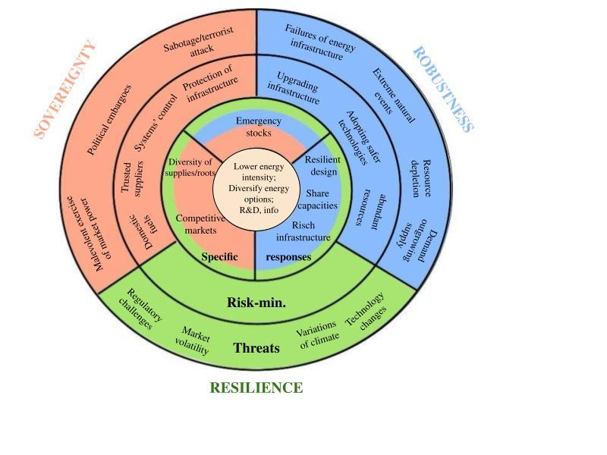
Adapted from: Cherp, A., & Jewell, J. (2011). The three perspectives on energy security: intellectual history, disciplinary roots and the potential for integration.

3.1 ‘Sovereignty’ glance at Italian energy transformation
To begin with, the sovereignty perspective emphasizes state control over energy resources, protection against geopolitical threats, and diversification of suppliers to ensure stable energy flows. Its vision can be labelled as political. Italy’s energy policy from 2019 to 2024 reflects these priorities through its response to the 2022 Ukraine crisis. Before applying this framework, it is crucial to focus on threats that match the sovereignty vision of security. Firstly, the EU imposed embargoes on Russian oil and petroleum products in 2022 and 2023. Although the policy is aimed at targeting the weak point of the exporter, cutting Russia from resource revenue, it also affected Italy as a consumer of Russian oil. Secondly, the diversion of Nord Stream is equated to a terrorist attack within the Cherp and Jewell frameworks. Having deprived Russia of an opportunity to increase the sales market, diversions have also jeopardized the stability and further volume of supplies. The suspension of gas flows through Nord Streams (due to sanctions and technical issues) reduced the volume of Russian gas on the Italian market, as the country received transit through Germany and Austria (Turkish Stream). Italy also receives Russian gas via Ukraine transit. However, the reduction of transit through Ukraine from 2022 in sum with changes in Austrian legislation led to a decrease in Russian gas volumes on the Italian market. Gazprom suspended gas deliveries to Italy due to Austrian regulatory changes effective 2022, which required new contracts that Gazprom did not sign. During the Russian-Ukrainian conflict Austria conducted a sanctions policy, which complicated transit schemes and disrupted the flow stability. These circumstances entailed the reduction of gas imports to Italy, in spite of Eni-Gazprom long-term contract supposed to make Italy the biggest Russian gas importer. This turn of events was reinforced by Eni initiation arbitration against Gazprom. Hereby, the combinations of events and EU-reaction restructured the energy market, demanding Italy to search for new gas flows. Thirdly, Russia's actions in the energy field can be disclosed as a malicious exercise of market power, as it occupied a leading position on the European energy market. In 2022 Gazprom repeatedly reduced gas supplies to Europe (e.g., reduction of gas volumes via Nord Stream 1 due to technical defects, suspension of Yamal-Europe gas pipeline). These actions combined supplies with additional requirements, such as payment in rubbles or lifting restrictions on the import of Russian fertilizers in exchange for increased supplies through Ukraine. Thus, Russian actions as it is state with energy-leverage, can be classified as ‘malicious exercise of market power’ from the European side. Even despite the fact of Russia acting in defence of its own interests. As a result of described events, the prices of oil and gas have skyrocketed, affecting the Italian economy. The energy crisis led to reducing energy consumption and required new solutions. While this is a clear example of the theoretical threats to sovereignty, two previous have a dual character for Italian landscape. Both embargo and attacks on gas pipelines targeted Russia as a victim; however, they also hit Italy to varying degrees. Uniting three threats, they suit the sovereignty perspective, as their roots are promotion of one's interests. So, embargo is a EU tool to punish Russia for its deviant behaviour, in the opinion of the EU, in the political area. Behind Russian ‘play’ with energy exports to Europe is the will to defend its interests and to weaken the opponent. Thus, the threats are united under the auspices of political consideration, matching sovereignty perspective frames.
Applying these licences on Italian risk-minimization policy, the linkage between theory and policy is traced. This section focuses on import and resources diversification and partially Plan Mattei as a national strategic initiative. Cherp and Jewell (2011) in their work link sabotage on strategic infrastructure with measure necessity to protect it. In the case of Italy this measure is not applicable, as Nord Stream pipelines were not directly connected to the Italian gas network. However, as it was discussed above, in sum with other events the Italian energy market was under impact. With the deprivation of Russia as a main fossil fuel supplier, Italy found itself in a situation of necessity to compensate for energy flows. The government did it via addressing alternative suppliers. The earlier establishment of energy relations, coupled with the creation of the TAP, bore fruit in 2021 with Azerbaijan. With the restructure of the energy market, Azerbaijan’s’ imports will take second place in 2024. Over the previous decade the energy role of Algeria was a crucial one. After 2022 it succeeded to replace Russia as the biggest gas importer. This status is reinforced with signing a long-term agreement in 2022, aiming to increase volumes of gas supply via TransMed. While Azerbaijan and Algeria occupy the biggest share of gas import, Italy had to build energy cooperation with other parties. To preserve trusted relations with Libya, Eni and Libya signed a long-term deal which will boost gas production from 2023. The attempts to fill the energy mix gap resulted in diversification of energy resources as well. Italy has boosted imports of LNG, mostly at the expense of the stable Qatar and emerged US. There were also attempts to boost import from Egypt; but the Middle East regional instability disrupted plans. Italy develops cooperation with Congo and Mozambique as an LNG importer. As for crude oil, due to environmental concerns, its share in Italy's energy mix is decreasing, and the policy is becoming less broad. Still, its stabilising consumption should be satisfied, and was achieved by establishing energy-relations with the US.
To infer this part, the Italian policy of supplier expansion matches with the strategy of ‘switching trusted suppliers’. The pivot of 2022 showed that even long-term supply-rich contracts can lead down. As Italy is a big economy highly dependent on foreign resources, this strategy is the key for its survival, especially under described circumstances. Notably, the country seeks to cooperate with numerous importers, diversifying fossil fuels energy flows. Theoretically, increasing the number of players on the Italian energy market could result in a competitive energy landscape – a specific response. Ideally, as their number grows, the leverage of each decreases. However, taking into account big shares and leverages of some suppliers, it is difficult to guarantee a fully competitive market.
As for other tactics, it is possible to view the notion of Plan Mattei as a manifestation of political and economic control over energy systems. Plan fosters cooperation with Algeria, Libya, and Congo for fossil fuels and renewable feedstocks. It is expressed in Italy’s engagement in South2Corridor and ELMED construction. Projects not only ensure diversification of supply of gas and hydrogen routes in future, but also grant Italy as Mediterranean hub. This role of bridge between African and European continents enhances its geopolitical influence and energy security.
Cherp and Jewell (2011) in their work link sabotage on strategic infrastructure with measure necessity to protect it. In the case of Nord Stream has shown that countries need to ensure the safety of their own infrastructure and that of their suppliers. In this light, it is possible to approach ‘infrastructure protection’ via its replacement on ‘infrastructure creation’. In this light, investments in such projects as GALSI, ELMED, Congesian LNG infrastructure reflect the will to maintain control over energy systems via investments. The argument about acquiring more power through investments in infrastructure is supported by other actions. Such as Italy’s involvement in launchment of the Poseidon pipeline, investments in Mozambique FLNG or Eni role in Egypt networks. Thus, two measures to securitize energy flows intersect. The path to security is not only to build up suppliers or supply roots, but also to develop energy production at home.
As for last but not least measures - switching to domestic fuels - the situation is complex. Italy’s fossil fuel birthplace is not excessive. This is evident from the steady decrease of natural gas and oil domestic production. Thus, on the issue of fossil fuels, Italy remains inevitably tied up on imports. However, approaching the question via clean fuels, the situation has bigger potential. As the paper showed, Italy actively implements measures toward decarbonization and green transition goals under EGD. The increase of renewables shares in total energy supply in the last decade and their stabilisation in last years proved it. It aligns with the RED mechanism of ‘Fit for 55’. Government encourages the usage of renewables and biofuels across sectors (e.g., transport, buildings, electricity). It incorporates white certificates, feed-in tariffs, auctions. The policy also allocates huge investments in on-shore and off-shore renewable plants creation (e.g., floating wind farms). Surprisingly, Cherp and Jewell (2011) highlighted domestic production as a national policy to minimize foreign energy dependence. Even so Italy has been successfully incorporating green fuels into the economy, this initiative was up-to-bottom. Meaning that it was the EU, as a supranational entity, who initiated the EGD. As a result of which, Member States were obliged to follow the policy of greening the economy. As the ‘sovereignty’ approach is mostly moved by realistic considerations, where states exist in a competitive environment, the case of EDG suits the scheme, breaking the logic. It proves that inter-state cooperation may result in absolute gains. Meaning that this way of increasing options of energy for one, does not decrease options for another. Hence, in spite of the ‘realist’ presumption of perspective, neoliberalism aligns with the framework. In addition, after decades of neglecting nuclear energy, the government recently changed its attitude. It realised that within existing circumstances to multiply energy independence was impossible. With the support of NECP recommendations under the auspices of EGD, Italy’s government embarked on the path of implementing the first steps towards nuclear development. This is an addition to perspective and neoliberal contradiction.

3.2 ‘Robustness’ glance at Italian energy transformation
The lenses of robustness narrow glance mainly to the technical side of energy security. Under this framework, it is possible to identify predictable risks to energy security, with which Italy faced in the analysed period. However, their scope is less than in the previous section. Italy did not face neither infrastructure failure nor extreme natural events. Still, some events suit frames. For instance, the EU policy towards Russian energy and Russian policy with energy supplies resulted in demand surpassing supply. As for other threats within robustness, the resource depreciation can be observed. However, Italian fossil fuels production covers less than 10% of demand. While gas and oil birthplace are declining and insufficient. The reliance on domestic resources is small and active supplier diversification throughout decades mitigate this risk.
Although there were not severe shocks, Italy implemented numerous measures, contributing to the robustness of its energy system. Up to 2030 €4.11 billion are allocated for transmission upgrades. For the most part these projects aimed at renewables incorporation in the energy system. For instance, achieving success in production of solar PV, promotes rooftop solar. This is one solution to the problem of grid congestion. Moreover, the deployment of such projects goes in line with EGD, aligning with AFIR, EED and RED initiatives. It includes the development of smart grids, which are digitised, advanced control systems with renewables incorporation. NRRP (2019) allocates about €3.61 billion for smart grids. This matches with the adoption of safer technologies, within the triad model. As for adoption of HVDC, The Adriatic Spine is one of the biggest projects, which aims to improve transmission across regions of the country. All in all, these initiatives contribute to infrastructure renewal. Meaning reflecting the changes in the energy system in existing networks. In this context, increasing importance of renewables is the novelty to what the infrastructure needs to adapt to. Italy is well-equipped with a transport network. In combination with prospective RES production, it can successfully implement ‘power to gas’ technology. Thus, having developed infrastructure expands the country's energy possibilities at home and as an international actor. In addition to developing national grid infrastructure (Adriatic Spine), the Malta-Italy Gas Pipeline is in the planning phase. It aims to perform a function of energy bridge, connecting Malta with the continent. So, Italy actively uses its sources to ensure an uninterrupted and united energy system.
Worth noting that commitment to this policy is reflected in infrastructure beyond Italy’s borders, fixed in the Mattei Plan. Italy’s investments in deployment of Agri-Hubs for biofuels (Kenya) assists supply networks for green energy feedstocks. Additionally, the deployment of centres in Morocco contributes to increasing professionals for grid management. These foreign investments demonstrate dedication to spreading new infrastructure. Moreover, they help to build sustainable and resilient networks with partners. In addition, investment in ELMED and SoutH2 Corridor expand the network. Even so, not all projects are successful. Italy is one of the countries interested in construction of the Poseidon Gas Pipeline. This would multiply and diversify supplies. However, due to regional instability and states energy interests’ tensions, the pipeline has a dim future. Combining Italy's geographical position with ELMED and SoutH2 pipelines, it makes Italy a energy distributor for Europe. Italian policy on enlarging infrastructure for hydrogen and electricity (AFIR) also aligned with robust risk minimization. For example, by 2026 it was targeted to build more than 20,000 of EV fast-charging stations across the country. Hence, Italy contributes to development of both foreign and domestic energy systems.
Since having emergency stock is one of the risk-minimization mechanisms both for sovereignty and robustness, it should be mentioned. Italy as a IEA member is obliged to follow certain rules regarding oil stocks. In general, its emergency stocks should be equivalent to at least 90 days of net oil import. Italy maintains this requirement. Remarkable, that implementation of this measure was achieved via inter-states cooperation. Approaching the issue through history, post-2012 reforms repurposed LNG terminals (e.g., Rovigo, Panigaglia) for emergencies and optimized storage operations to handle peak demand.
In addition, contribution in energy efficiency of systems can expand ‘robustness’ licences. Under the EED directive, Italy aims to reduce primary energy consumption to 43% by 2030; moreover, it adopts the EU's 0.8% annual savings obligation. The realisation of goals is ensured with white certificates. Efficiency projects across sectors, especially, in the building sector. Through ‘Ecobonus’ the government renovates 3% of floor area. The initiative seeks to make buildings energy effective and seismically stable. There is also a wide financial support of NZEB. Modernizing ways of energy consumption contribute to reducing the load on the power system.
All in all, the network creation contributes to energy efficiency and multiplying grids capacity. This is crucial in circumstances of rising role of such facilities as EV charges. More developed and updated grid system would better handle increased electricity demand from EV. Moreover, usage of ‘power to gas’ technology would help to store energy for a long time. This is one of possible specific responses, which balances supply-demand in emergency situations or peak seasons. In the case of Italy, expansion of infrastructure has a strategic importance for the county. Its proximity to resource rich countries allows it to be a transit point for fossil fuels.
Thus, applying a robust energy security perspective, Italy strives for infrastructure redundancies. This way of securitizing can be divided into two three. One is about uniting the national landscape to provide energy to the whole country. It is important because it contributes to uninterrupted operation of all structures, economy sectors, and households. It translates into satisfaction of the society, the work of the economy and, thus, energy security. Second is modernizing infrastructure in line with changes in energy politics, which ensures smooth performance of the energy. These two arguments contribute to energy security not from classical ‘out’ presumption, but from ‘inner’. Third refers to creating infrastructural linkage with suppliers. This glance is partially a narrowing sovereignty licence to ‘trusted suppliers’ and approaching it from another angle. Meaning building not only agreements on paper, but also constructing physical routes.

3.3 ‘Resilience’ & Neoliberal glance at Italian energy transformation
The resilience perspective views energy security as the ability to adapt to unpredictable risks, through flexible, diverse systems. This may include market volatility, geopolitical crises, and climate change. But risk-defining is not the primary focus of the resilience perspective. It acknowledges the complexity of energy systems and does not provide risk-minimanizations strategies. On the contrary, it looks for more general energy system traits that distribute risks and prepare for unexpected events to guarantee protection against any threats. This perspective is enriched by neoliberalism, which emphasizes market liberalization, institutional cooperation, and complex interdependence to achieve absolute gains. Italy’s energy policy from 2019 to 2024 reflects these principles through market-driven reforms, EU alignment, and international partnerships, enhancing adaptability to unforeseen disruptions.
In the 2000s Italy entered the phase of market liberalization. By now the Italian oil and gas market remains shared between several companies with ENI occupying a dominant position as an integrated actor. However, liberalisation in the gas and electricity market is still in process. New legislative framework, adopted by 2024 and 2025, aims to lower barriers for new participants and create favorable conditions for innovative market models. Thus, in this place the resilience framework matches with neoliberal approach.
Remarkably, the EU, as a neoliberal entity, acknowledges the fact of climate change. As analysis has shown, Italy as a Member State, actively implements policy to respond to climate change issues. Country aligns with EGD directives (RED, EED, AFIR) and REPowerEU enhances resilience. The EGD acts as a factor that changed the long-term policy. By 2030, Italy's 30% national renewable energy aim falls short of the EU's 32% target. It has ambitious sector-specific targets (e.g., 22% in RES-T and 55% in RES-E by 2030). Additionally, the wide support of biofuels and their incorporation within grid systems proves the commitment to decarbonization goals. This feature connects ‘resilience’ and European neoliberalism.
There are certainly a number of barriers on the way to achieving the goals. They can be identified as ‘regulatory challenges’. It is not the threat on a large and unpredictable scale. On the contrary, these obstacles are built within almost any system. For instance, administrative and bureaucratic barriers are part of the system which interferes realisation of modern projects. Thus, in order to make the overall system effective, fast-responsive and flourishing, Italy implements measures on removal of these barriers.
The threat of technology change is mitigated by constant investments in grid infrastructure modernization and upgrading, which is mentioned in ‘robustness’ perspective.
Continuing creating a linkage between neoliberalism and resilience, the complex interdependence can be an argument. While ‘sovereignty’ approaches Plan Mattei as a switch to trusted suppliers, ‘resilience’ can approach it through complex interdependence. Fostering relations with African countries by economic cooperation creates economic reduces conflict risks and enhances resilience to geopolitical shocks. More specifically, in the case of Italy it is a tool to address the migration issue, avoiding playing zero-sum games. Thus, the creation of complex interdependence between Italy and Africa, in this paper was analysed via energy cooperation. I believe that linkage between resilience and interdependence is in variation. Meaning having different routes of energy sources. It can be reflected both in diversity of energy sources and diversity of suppliers. Thus, it makes an intersection between neoliberalism and resilience. Approaching the concept of variety through variation of energy sources, Italy also experiences shifts. New glance at nuclear policy is a potential resource diversification beyond fossil fuels and renewables.
In general, resilience seeks to make energy systems flexible, adaptable and various. As research has shown, Italy strives for this via a vast energy policy. The concept of resilience can be summarized as a general response that unites all three approaches under the umbrella of resilience. It is a reason why its analysis is almost impossible without referring to ‘sovereignty’ and ‘robustness’. The higher overview proved this interconnectedness and showed Italy's policy in each kind of response.
Final, all specific responses are common for all three perspectives. Italy implements almost all policies. First, its policy in reduction of energy intensity contributes to an economy less sensitive to disruptions (actions under EED). Second, diversification of suppliers assures a variety of flows of fossil fuels. The necessity is confirmed by increased LNG imports, as a temporary solution, due to environmental considerations. It is reinforced by the revival of nuclear policy and active incorporation of renewables. Thus, two facts unite under the diversification of energy options. Third, policy towards infrastructure abundance and its multi-vector approach aligned with investments in research and development. The research demonstrated that the country makes huge investments in improvement and extension of infrastructure. To sum up, Italy matches all specific responses of the Energy Security Triad.
In this regard, the case of Italy and transformation of its policy in 2019-2024 proves the necessity of a complex contemporary approach towards energy security. Indeed, energy systems have increased in their complexity. It means that it is not enough to use one approach, while ignoring the others. A step in one direction must necessarily be backed up by a step in the other. Conducting a comprehensive and multi-dimensional energy policy has become crucial for making systems sustainable. It both helps to preserve resilience in case of unpredictable crises and to make daily-operation of energy systems efficient and uninterrupted. These considerations are supported by the necessity to unite three approaches of triad.

Conclusion
Italy is one of the biggest energy consumers within the frameworks of the European Union. The fullness of its national energy mix is highly dependent on fossil fuels imports. The combination of these factors provides a field to study how Italy manages its energy portfolio in circumstances of changes happening in the 2019-2024 period. The study was framed within the theoretical lenses of neoliberalism and the Energy Security Triad (sovereignty, robustness, and resilience perspectives), allowing structurally approach the topic. Under these licences study traces the transformation of Italian energy policy.
The paper is structured in the following way. First, it provides a deep explanation of the theoretical framework, explaining its applicability to the case of Italy. Then via comparison of International Energy Agency reports of 2009 and 2016 study indicates the dynamics of national policy evolution. The comparison by sector confirmed Italy’s coal phase-out, transition towards green fuels, and showed the dynamic of oil and gas imports in recent decades. The overview of the electricity sector has revealed the trends of electricity consumption and construction of facilities. It has also provided insights on evolution and liberalisation of the Italian energy market. The historical background was strengthened by the analysis of statistics in four areas. The electricity generation indicated the decreasing role of oil and gas and substantive contribution of renewables. Analysis of resource domestic production in line with energy supply and total consumption confirmed numerically Italy’s dependence on imports. Especially, sharp need for natural gas. Thus, the statistical analysis and IEA report comparison provided a ground for further analysis of Italian energy strategy.
The next step was the identification of main turning points within the analysed period and Italian responsive politics. Chapter begins with analysis of the European Green Deal, as an engine of national decarbonization policy. Due to the fact that this notion is broad, only several initiatives are in the scope of study. It includes Renewable Energy Directive (RED), Energy Efficiency Directive (EED) and Alternative Fuels Infrastructure Regulation (AFIR). The choice of mechanisms is conditioned by the objective to match the triad in the analytical part. Further through the perspective of three selected mechanisms, the paper viewed Integrated National Energy and Climate Plan (2019) and Italian National Recovery and Resiliency Plan (2021). Analysis of documents has provided several insights and strong alignment with EU decarbonization goals. First, Italy mapped out a 30% of renewable share, which trails the EU-wide goal of 32% by 2030. However, some sector-specific targets, such as transport, are even more ambitious than on EU level. Second, approaching INECP and NRRP via RED, EED and AFIR helped to identify Italy’s politics to fit the targets. In this way were revealed energy-efficiency projects, such as Ecobonus, NZEB; policy on renewables expansion, such as investments on development of on-shore and off-shore technologies; and measures to integrate green fuels in grid infrastructure. In general, the Italian government allocates big investments for the realization of all projects, confirming its commitment to green transition.
The second identified factor is the Russian-Ukrainian crisis. Research provides an overview on the reaction of the European energy market to subsequent sanctions on Russian energy imports. The restructure of the European energy landscape put Italy in a position of necessity to diversify energy flows. The demand was reinforced with the fact of Russia being a major gas supplier to Italy. As natural gas, as a low-emission resource, occupies a prioritised position in the national energy mix, it is in the centre of analysis. Findings show that Azerbaijani, Libya and Algeria exports to Italy occupy the biggest share in new realities. Besides diversification of suppliers, the state resorted to LNG imports, as a short-term solution; and plans for nuclear revival and a long-term solution. By 2024 the biggest importers of LNG are the US, newly entered, and Qatar. In addition to searching for new importers, Italy actively invests in new energy corridors. Some projects are in the development stage, while the future of others is uncertain. All in all, the enlargement of the infrastructure grid in combination with Italy’s geography strengthened its strategic position as a Mediterranean energy hub. This argument is backed with Plan Mattei, which the article approaches as a response to 2022 events. The plan seeks to establish closer economic ties with African nations, and, thus, resolve part of the party's problems. From the strategy, the article roots the initiatives, related to investments in energy infrastructure and energy supplies.
The tried step was the analysis of Italy’s policy through the prism of neoliberalism and energy security triad. These frameworks provide an opportunity to glance at Italian energy policy both from the side of ‘Italy as a separate state’ and from the side of ‘Italy as a part of EU’. As a result of the research, the hypothesis was proved. Indeed, within the period of 2019-2024 the character of Italy’s policy was complex and wide-ranging. It is observed in its investments in infrastructure, diversification of energy sources and roots. This policy corresponds to measures of securitizing the country from an energy perspective. Italy expands energy resource options via cooperation with the EU; while diversifying fossil flows on national level. Moreover, the state experiences a thaw towards nuclear energy. This highlights the necessity of further energy sources diversification, driven by EGD ambitious goals and high costs on energy. In circumstances of being an import-dependent country, this policy has strategic and vital importance. Additionally, the country actively invests in infrastructure, which has a dual effect on security. From one side, these investments help to maintain control over energy roots. From another side, modernization and expansion of domestic infrastructure eliminates inner threats to energy system operation. All in all, the complexity and sophistication of modern energy systems necessitates a multidimensional energy policy that Italy has successfully implemented.
To sum up, Italian energy policy in 2019-2024 has a complex and multidimensional character, responding to the dynamic nature of the energy market. In these circumstances Italy succeeds in keeping balance between national interests and EU-wide goals.
The study opens several avenues for future research. First, the economic implications of Italy's energy diversification and green transition deserve deeper exploration. Although this study focused on specific measures (RED, EED, AFIR), it did not cover other aspects of 'Fit for 55'. Second, the potential for nuclear energy in Italy is promising. Given Italy's historical reluctance to nuclear power after Chernobyl, it would be interesting to study public perception, regulatory frameworks, and technological advances in small modular reactors (SMRs) to assess the feasibility of integrating nuclear power. Third, the effectiveness of the Mattei Plan in the long term, particularly its economic and geopolitical impacts, remains under-researched due to its recent implementation. Future studies could evaluate its impact on Italy's relations with Africa and its role in ensuring energy security amid regional instability.

Reference list
Abderrahmane, A. (2023). If well managed, Italy and Algeria could build a strong and viable geo-economic bridge between both shores of the Med. Atlantic Council.
Amaglobeli, D., & Roaf, J. (2022). Reducing dependence on Russian gas: Energy savings and investment needs in the EU (IMF Working Paper No. 2022/145). International Monetary Fund.
Armaroli, N., & Barbieri, A. (2021) Il dilemma dell'idrogeno nella transizione energetica italiana. Nature Italy (Nat Italy)
Ballotpedia. (n.d.). Italian referendum on nuclear power growth, 2011.
Batzella, F. (2024). Slowly but surely? Assessing EU actorness in energy sanctions against Russia. Energy Policy, 192, 114233
Bertolini M, Blasi S. (2021) The role of the DSos in the energy transition towards sustainability. A case study from Italy. In: Sedita SR, Blasi S, editors. Rethinking clusters, place-based value creation in sustainability transitions. Berlin: Springer. pp. 66–77
Brondi, S., Armenti, A., Cottone, P., Mazzara, B. M., & Sarrica, M. (2014). Parliamentary and press discourses on sustainable energy in Italy: No more hard paths, not yet soft paths. Energy Research & Social Science, 2, 38-48.
Candelise, C., & Ruggieri, G. (2020). Status and evolution of the community energy sector in Italy. Energies, 13(8), 1888.
Cherp, A., & Jewell, J. (2011). The three perspectives on energy security: intellectual history, disciplinary roots and the potential for integration. Current opinion in environmental sustainability, 3(4), 202-212
Council of the European Union. (n.d.). Sanctions against Russia explained.
de Vincenzo, D. (2022). NextGenerationEU tra pandemia, guerra e transizione energetica. Documenti geografici, (1), 23-36.
Di Nucci, M. R. D. (2006). The nuclear power option in the Italian energy policy. Energy & Environment, 17(3), 341-357.
Di Nucci, M. R., & Prontera, A. (2023). The Italian energy transition in a multilevel system: between reinforcing dynamics and institutional constraints. Zeitschrift für Politikwissenschaft, 33(2), 181-204.
Divercity Times. (n.d.). Europe natural gas price.
Ember. (2021). Top 15 wind and solar power countries in 2020. Ember Energy.
Enel. (2024). Enel and Ansaldo Nucleare, research agreement on new generation reactors
Enerdata. (2023). Italy energy report. Enerdata.
Eni. (2018). World oil and gas review 2018
European Commission. (2019). Integrated National Energy and Climate Plan (NECP): Italy.
European Commission. (2019). What is the European Green Deal?
European Commission. (2020). Investing in a climate-neutral, circular economy: The European Green Deal investment plan
European Commission. (2020). Offshore renewable energy strategy
European Commission. (2020). The European climate law.
European Commission. (2020). The just transition mechanism: Making sure no one is left behind
European Commission. (2023). The European Green Deal – Delivering the EU’s 2030 climate targets: Fit for 55 – Commission proposals.
European Commission. (2024). Guidance document on heating and cooling accounting in Articles 15a, 22a, 23 and 24 of the revised DIRECTIVE (EU) 2018/2001 on promotion of energy from renewable sources [Communication from the Commission].
European Commission. (2024). Integrated National Energy and Climate Plan 2021–2030: Italy
European Commission. (2024). Renewable Energy Directive. European Commission.
European Commission. (2024). Renewable energy statistics. Eurostat Statistics Explained.
European Parliament and Council of the European Union. (2023). Directive (EU) 2023/1791 of the European Parliament and of the Council of 13 September 2023 on energy efficiency and amending Regulation (EU) 2023/955 (recast) (OJ L 231, pp. 1–111)
European Parliament and Council. (2023). Regulation (EU) 2023/1804 of the European Parliament and of the Council of 13 September 2023 on the deployment of alternative fuels infrastructure, and repealing Directive 2014/94/EU (OJ L 234, 22.9.2023, p. 1–47).
European Parliament, & Council of the European Union. (2018). Directive (EU) 2018/844 of the European Parliament and of the Council of 30 May 2018 amending Directive 2010/31/EU on the energy performance of buildings and Directive 2012/27/EU on energy efficiency (Text with EEA relevance). Official Journal of the European Union, L 156, 75–91.
Eurostat. (2025). EU trade with Russia - latest developments.
Gazprom. (2009). 40 years of Russian gas supplies to Italy.
Gestore dei Servizi Energetici (GSE). (2017). Rapporto delle attività 2017 [Annual report].
Gestore dei Servizi Energetici (GSE). (2019). Rapporto statistico 2019
Giordano, G., Governatori, M., & Panzeri, D. (2022). Energy without Russia: The case of Italy. The consequences of the Ukraine war and the EU sanctions on the energy sector in Europe. Friedrich-Ebert-Stiftung
GIS Reports Online. (2023). Can Italy navigate Libya’s rough political waters in energy?
Governo Italiano. (2024). Piano strategico Italia-Africa: Piano Mattei [Strategic plan]. Presidenza del Consiglio dei Ministri.
Institute for Energy Economics and Financial Analysis. (2025). European LNG tracker.
International Energy Agency. (2009). Energy policies of IEA countries: Italy 2009 review. OECD
International Energy Agency. (2016). Energy policies of IEA countries: 2016 review - Italy. OECD/IEA.
International Energy Agency. (2023). Italy 2023: Energy policy review.
International Energy Agency. (n.d.). Egypt - Natural gas. IEA.
Keohane, R. O. (1984). After hegemony: Transatlantic economic relations in the next decade. The International Spectator, 19(1), 3-9.
Keohane, R. O., & Nye Jr, J. S. (1973). Power and interdependence. Survival, 15(4), 158-165.
Khan, F., & Rapposelli, A. (2024). Determination of sustainable energy mix to ensure energy security in Italy amidst Russian-Ukraine crises. Renewable Energy, 231, 120976.
Knodt, M., & Kemmerzell, J. (Eds.). (2022). Handbook of energy governance in Europe. Springer International Publishing.
Krikštolaitis, R., Bianco, V., Martišauskas, L., & Urbonienė, S. (2022). Analysis of electricity and natural gas security. A case study for Germany, France, Italy and Spain. Energies, 15(3), 1000.
Lovins, A. B., & Lovins, L. H. (1982). Brittle power: Energy strategy for national security.
Lumeno, F. D. L. (2024) Italy's Evolving Mediterranean Strategy: Migrations, Economic Diplomacy, and Regional Challenges from the Arab Springs to the Mattei Plan.
Nascia, L., Simone, G., & Pianta, M. (2023). Aligning social and climate objectives: The effects of the fossil fuel price crisis – The case of Italy (Chapter 5). European Trade Union Institute (ETUI).
Nugrahani, H. S. D. (2024). EU Energy Security Strategy: The Impact of the Russia-Ukraine War on the Energy Sector (2022-2024). International Journal of Educational Research & Social Sciences, 5(4), 611-626.
Oana, I. E., Moise, A. D., & Truchlewski, Z. (2025). Demand-side constraints on European solidarity for energy sanctions: Experimental evidence from seven EU countries. European Union Politics, 14651165251318955.
Pastore, L. M., & de Santoli, L. (2025). Socio-economic implications of implementing a carbon-neutral energy system: A Green New Deal for Italy. Energy, 135682.
Presidenza del Consiglio dei Ministri. (n.d.). Strengthening the Ecobonus for energy efficiency. Italia
Prontera, A. (2018). Italian energy security, the Southern Gas Corridor and the new pipeline politics in Western Europe: from the partner state to the catalytic state. Journal of International Relations and Development, 21, 464-494.
Prontera, A. (2024). Winter is coming: Russian gas, Italy and the post-war European politics of energy security. West european politics, 47(2), 382-407.
Simone, G., & Pianta, M. (2022). Inflation and counter-inflationary policy measures: The case of Italy (No. 83-4). IMK Study.
Simonelli, F., Fantappié, M. L., & Goretti, L. (2024). The Italy-Africa Summit 2024 and the Mattei Plan: Towards Cooperation between Equals. IAI Commenraties, 11
Statista. (2023). Natural gas prices for households in Germany from 2014 to 2022 (in euros per kilowatt-hour) [Graph].Statista
Statista. (2023). Natural gas prices for households in Italy from 2014 to 2022 (in euros per kilowatt-hour) [Graph]. Statista
Statista. (2023). Primary energy consumption in selected countries in Europe in 2023 (in exajoules) [Graph]. Statista.
Statista. (2025). Natural gas prices for households in France from 2013 to 2024, semi-annually (in euros per kilowatt-hour) [Graph]. Statista.
United Nations Environment Programme. (2025). Our work in Africa.
United Nations Framework Convention on Climate Change. (2015). Paris Agreement.
Watson Farley & Williams. (2023, September 14). The Italian hydrogen strategy.
World Bank. (2018). The impact of the 2014-16 oil price collapse
Yergin, D. (2006). Ensuring energy security. Foreign affairs, 69-82.

Statista. (2023). Primary energy consumption in selected countries in Europe in 2023 (in exajoules) [Graph]. Statista.
Enerdata. (2023). Italy energy report. Enerdata.
Giordano, G., Governatori, M., & Panzeri, D. (2022). Energy without Russia: The case of Italy. The consequences of the Ukraine war and the EU sanctions on the energy sector in Europe. Friedrich-Ebert-Stiftung
Keohane, R. O., & Nye Jr, J. S. (1973). Power and interdependence. Survival, 15(4), 158-165.
Cherp, A., & Jewell, J. (2011). The three perspectives on energy security: intellectual history, disciplinary roots and the potential for integration. Current opinion in environmental sustainability, 3(4), 202-212.
Ember. (2021). Top 15 wind and solar power countries in 2020. Ember Energy.
Gestore dei Servizi Energetici (GSE). (2017). Rapporto delle attività 2017 [Annual report].
International Energy Agency. (2016). Energy policies of IEA countries: 2016 review - Italy. OECD/IEA.
International Energy Agency. (2009). Energy policies of IEA countries: Italy 2009 review. OECD
Statista. (2023). Natural gas prices for households in Italy from 2014 to 2022 (in euros per kilowatt-hour) [Graph]. Statista
Statista. (2023). Natural gas prices for households in Germany from 2014 to 2022 (in euros per kilowatt-hour) [Graph].Statista
Statista. (2025). Natural gas prices for households in France from 2013 to 2024, semi-annually (in euros per kilowatt-hour) [Graph]. Statista.
Ballotpedia. (n.d.). Italian referendum on nuclear power growth, 2011.
Enel. (2024). Enel and Ansaldo Nucleare, research agreement on new generation reactors
International Energy Agency. (2023). Italy 2023 energy policy review
World Bank. (2018). The impact of the 2014-16 oil price collapse
Gestore dei Servizi Energetici (GSE). (2019). Rapporto statistico 2019
International Energy Agency. (2023). Italy 2023: Energy policy review.
United Nations Framework Convention on Climate Change. (2015). Paris Agreement.
European Commission. (2019). What is the European Green Deal?
European Commission. (2020). Investing in a climate-neutral, circular economy: The European Green Deal investment plan
European Commission. (2020). Offshore renewable energy strategy
European Commission. (2020). The European climate law.
European Commission. (2020). The just transition mechanism: Making sure no one is left behind
European Commission. (2023). The European Green Deal – Delivering the EU’s 2030 climate targets: Fit for 55 – Commission proposals.
European Commission. (2024). Renewable Energy Directive. European Commission.
European Commission. (2024). Guidance document on heating and cooling accounting in Articles 15a, 22a, 23 and 24 of the revised DIRECTIVE (EU) 2018/2001 on promotion of energy from renewable sources [Communication from the Commission].
European Parliament, & Council of the European Union. (2018). Directive (EU) 2018/844 of the European Parliament and of the Council of 30 May 2018 amending Directive 2010/31/EU on the energy performance of buildings and Directive 2012/27/EU on energy efficiency (Text with EEA relevance). Official Journal of the European Union, L 156, 75–91.
European Parliament and Council of the European Union. (2023). Directive (EU) 2023/1791 of the European Parliament and of the Council of 13 September 2023 on energy efficiency and amending Regulation (EU) 2023/955 (recast) (OJ L 231, pp. 1–111)
European Parliament and Council. (2023). Regulation (EU) 2023/1804 of the European Parliament and of the Council of 13 September 2023 on the deployment of alternative fuels infrastructure, and repealing Directive 2014/94/EU (OJ L 234, 22.9.2023, p. 1–47).
European Commission. (2019). Integrated National Energy and Climate Plan (NECP): Italy.
Presidenza del Consiglio dei Ministri. (n.d.). Strengthening the Ecobonus for energy efficiency. Italia
Watson Farley & Williams. (2023, September 14). The Italian hydrogen strategy.
Oana, I. E., Moise, A. D., & Truchlewski, Z. (2025). Demand-side constraints on European solidarity for energy sanctions: Experimental evidence from seven EU countries. European Union Politics, 14651165251318955.
Council of the European Union. (n.d.). Sanctions against Russia explained.
Eurostat. (2025). EU trade with Russia - latest developments.
International Energy Agency. (2023). Italy 2023: Energy policy review.
Divercity Times. (n.d.). Europe natural gas price.
Gazprom. (2009.). 40 years of Russian gas supplies to Italy.
International Energy Agency. (2023). Italy 2023: Energy policy review.
Abderrahmane, A. (2023). If well managed, Italy and Algeria could build a strong and viable geo-economic bridge between both shores of the Med. Atlantic Council.
GIS Reports Online. (2023). Can Italy navigate Libya’s rough political waters in energy?
International Energy Agency. (n.d.). Egypt - Natural gas. IEA.
European Commission. (2024). Integrated National Energy and Climate Plan 2021–2030: Italy
United Nations Environment Programme. (2025). Our work in Africa.
Governo Italiano. (2024). Piano strategico Italia-Africa: Piano Mattei [Strategic plan]. Presidenza del Consiglio dei Ministri.

